s

Hitachi Solutions Europe

Cloud Health

Check




Client Name:
CQC

Document Number:
0.
1

Submission Date:
9
th

June

2026

Status:
DRAFT

All rights reserved. Information contained in this document and associated documents is confidential, proprietary to, and constitutes the trade secrets of, Hitachi Solutions Europe Ltd. Without prior written permission from Hitachi Solutions Europe Ltd, it may not be reproduced (in any form, in whole or in part) or disclosed to any other parties, employees, contractors, agents or representatives other than those with a need to know the information contained in this document solely for the purpose of the project.
© Copyright Hitachi Solutions Europe Ltd, 2026
Table of Contents
Introduction 4
Scope & Structure 4
Cloud Health Check Domains 5
Segmentation Framework 6
Cloud Governance 10
Objective 10
Workloads in Scope 10
Observations - Cloud Governance 11
Observations - Tagging 19
Observations - Policy 25
Security: Defender for Cloud 27
Observations 27
Security: Network 27
Objective 27
Workloads in Scope 28
Observations - Network Segmentation 28
Observations - Private Endpoints 34
Observations - Network Watcher 35
Security: External Exposure 36
Objective 36
Workloads in Scope 36
Observations - Public IP Addresses 36
Observations - Azure Firewall 39
Observations - Web Application Firewall (WAF) 39
Security: Secret & Key Management 41
Observations - Key Vaults 41
Security: RBAC & Access 43
Objective 43
Workloads in Scope 43
Observations 43
Operations & Observability 44
Objective 44
Workloads in Scope 44
Observations 44
Workload: Application Services 46
Objective 46
Workloads in Scope 46
Deployment Summary 46
Observations - API Management 47
Observations - Logic Apps 49
Observations - Function Apps 50
Observations - App Service Plans 52
Workload: Storage 54
Objective 54
Workloads in Scope 54
Observations 54
Workload: Data Services, Data Storage 56
Objective 56
Workloads in Scope 56
Deployment Summary 56
Observations 56
Workload: Data Services, Data and AI Platform 59
Objective 59
Workloads in Scope 59
Deployment Summary 59
Observations 59
Workload: Compute 66
Objective 66
Workloads in Scope 66
Observations 66
Key Metrics – VM’s 67
Key Metrics - VMs per Size Category 67
Key Metrics - VM SKU Breakdown 67
FinOps and Cost Management 69
Objective 69
Workloads in Scope 69
Observations 69
Health Check Conclusions / Final observations 72
Maturity Scorecard 72
Maturity Scorecard - Results 72
Contacts 74

Introduction
This Cloud Health Check Report presents the detailed technical findings of the Azure assessment conducted for the Care Quality Commission (CQC) by Hitachi Solutions.
As part of this Cloud Assessment, three deliverables will be generated:
- ACS 922: Cloud Health Check (this document)
- ACS 921: Cloud Assessment Report
- ACS 920: Cloud Assessment Presentation
While the Cloud Assessment Report defines the strategic vision and roadmap ("the why" and "the how"), this Health Check provides the factual "what" via analysis of the current estate.
The objective is to baseline the Azure footprint and flag configurations that introduce risk, inefficiency, or non-compliance with policy. It identifies specific configurations that introduce risk, inefficiency, or governance drift, while also highlighting areas of strong compliance.

Scope & Structure
The analysis is structured around three core pillars, providing a comprehensive view of the platform's health:
- Cloud Governance: Evaluating the structural foundation of the estate, including Management Group hierarchy, subscription organisation, cost transparency, and the effectiveness of metadata (tagging) standards.
- Security Posture: Assessing the integrity of the "Zero Trust" perimeter, focusing on network segmentation (Hub & Spoke), external exposure points (Public IPs, Firewalls), and secret management (Key Vaults).
- Workload Hygiene: Reviewing the configuration of specific compute and data services, including Virtual Machines, Storage Accounts, and PaaS resources, to identify opportunities for cost optimisation and operational modernisation.

Cloud Health Check Domains
To ensure a holistic assessment, the review is broken down into specific technical domains covering both the foundational Landing Zone and the Workloads hosted within it. The table below outlines the specific resources and metrics evaluated within each domain:
# | Area | Domain | Workloads | Metrics
1 | Landing  Zone | Cloud  Governance | Resources, Resource Groups,  Subscriptions, Locations | Resource distribution, tag coverage, organisational structure
2 | Landing  Zone | Security | Virtual Networks, Subnets, NSGs,  Private Endpoints, Public IPs, Route  Tables, Azure Firewall, WAF, Key  Vaults | NSG coverage, private endpoints, VNet design, public exposure, firewall rules,  WAF policies
3 | Landing  Zone | Operations &  Observability | Log Analytics, Application Insights,  Action Groups, Recovery Services  Vaults, Availability Tests,  Dashboards | Monitoring coverage, alert hygiene, backup posture, observability fragmentation
4 | Workload | Application  Services | App Service Plans, Function Apps,  Logic Apps, Web Apps | Instance utilization, scaling configuration, tier appropriateness, resource waste
5 | Workload | Storage | Storage Accounts | Public access, encryption, firewall rules, secure transfer
6 | Workload | Database and  Data & AI  Platform | SQL Databases, SQL Servers,  Synapse, Fabric, Databricks, ML  Studio, Foundry | Public endpoints, encryption, auditing
7 | Workload | Compute | Virtual Machines | Public IP exposure, disk encryption, OS support, VM sizing

Reading This Report
The findings in this document are categorised by the below risk priority:
- ● High Risk: Immediate vulnerabilities or major governance gaps (e.g., public exposure of sensitive assets, 0% Secure Scores).
- ● Medium Risk: Deviations from best practice that impact manageability or cost efficiency (e.g., inconsistent tagging, orphaned resources).
- ● Low Risk / Good Practice: Configurations that align with industry standards and should be preserved as patterns.

Segmentation Framework
The Azure estate contains thousands of resources. To make the data digestible, this chapter establishes the foundational framework for grouping the technical findings presented throughout the entirety of this report.
By defining these primary clustering themes upfront, we provide a multi-dimensional view of the estate to ensure that the governance, security, and cost metrics in the following chapters are contextually relevant and easy to navigate.
To provide this clarity, the segmentation analysis evaluates the estate across three organisational and metadata structures:
- Management Group Branches: The authoritative hierarchy defining the policy and access regimes for the estate.
- Environment Classifications: Logical groupings of subscriptions based on their path within the management hierarchy (e.g., Production vs. Sandbox), rather than relying on inconsistent subscription names.
- Service Line Mappings: Workload-centric groupings derived from service-based tags and naming conventions, which link underlying IT resources directly to CQC business services.

Management Group
The CQC tenant currently maintains four top-level Management Groups under the Tenant Root. Because these groups dictate policy and access boundaries, they provide the primary structural lens for analysing the health and risk posture of the estate.
Management  Group | Role | Child  MGs | Direct | Total  Subs | Status
CQC | CAF-aligned target hierarchy.  Landing Zones (Corp / Online),  Platform (Connectivity / Identity / Management / Security), Sandbox. | 4 | 0 | 4 | Built, in progress
mg-cqc-legacy | Legacy hierarchy. Atos-era workloads migrated circa 2020. Holds the bulk of operational state including the four VDC subscriptions. | 10 | 19 | 36 | Being retired
mg-cqc-root | Earlier ALZ/CAF attempt. Overlaps with the new CQC hierarchy. Empty intermediate groups suggest reserved capacity rather than active use. | 4 | 0 | 20 | Being retired
mg-  decommissioned | Subscriptions awaiting decommission. Policy should enforce read-only at this scope. | 0 | 3 | 3 | Being retired

Environments
Environment is being derived from the Management Group path.
Environment | MG Path ends with
Production (Legacy) | ProdApps (under mg-cqc-legacy)
UAT (Legacy) | UATApps (under mg-cqc-legacy)
Dev/Test (Legacy) | DevTest (under mg-cqc-legacy)
Development RP (Legacy) | DevRP (under mg-cqc-legacy)
GFC (Legacy) | GFC (under mg-cqc-legacy)
Core Infra (Legacy) | CoreInfrastructure (under mg-cqc-legacy)
Legacy (Unclassified) | Direct child of mg-cqc-legacy
Production (mg-cqc-root) | mg-prod-apps (under mg-cqc-root)
Pre-Production (mg-cqc-root) | mg-preprod-apps
Test (mg-cqc-root) | mg-test-apps
Development (mg-cqc-root) | mg-dev-apps
Platform (CAF Platform group) | Connectivity / Identity / Management /  Security
Sandbox | Sandbox / mg-sandbox
Landing Zone (Empty) | Corp / Online (under Landing Zones)
Decommissioned | mg-decommissioned
Root (Bootstrap) | Tenant Root Group (direct)

Service Lines
Resources are classified into service lines using a tag-led approach, with IT-Service-Name acting as the signal for this classification.
Top-Level Service  Line | Example Values (from tags)
Core Business  Applications | Provider Portal, Give Feedback on Care, Direct Monitoring, Infection Control, SOAD, MHA  Portal, PeopleFinder, Mental Health Apps, Covid 19 Enquiry, CRM, Production
Regulatory Platform | Regulatory Platform (RP), Fees Calculation, Fees Monitoring, GL3 E2E Data Migration, Siebel  Decommission Migration, ManualFeeCalculation, RP-EDP Integration
Data and Analytics | Enterprise Data Platform (EDP), DataScience, Databricks, Power BI, Historic Reports, SQL  Managed Instance, Data Science Training
Integration Services | Azure Integration Services (AIS), ESB, Service Bus, API Management, KingswaySoft Integration  Toolkit, File Upload, Document Migration, FTP, SFTP
Finance and  Corporate | Finance, Finance System, Dynamics Finance and Operations, IBM SPSS Licence, Print Services
Identity and  Security | Azure AD, Entra ID, Azure AD Connect, Application Registrations, Entra App Proxy, Key Vault,  Sentinel, SOC tooling, NPS
Core Platform | Azure Platform, Landing Zone, Platform Identity, Platform Connectivity, Virtual Networks,  DNS, IPAM, DDOS, AVS, Subscription Automation, Terraform Backend, VDC0-CoreInfra, VDC1
DevOps and  Automation | Azure DevOps, Azure DevOps Pipelines, DevOps Agents, Test Automation, Subscription  Automation, JML Automation, Automation Accounts
End-User  Computing | RDS, Remote Desktop Services, RDS Session Hosts, HSCN Proxy, Ivanti Connect Secure, VMSS  PLZ
Monitoring and  Observability | Application Insights, Log Analytics, Dashboards, Workbooks, Web Tests, Alerts, Azure Monitor
Proof of Concept | POC, AltiusPOC, databricks-poc, proof-of-concept, sandbox and experimental services

Cloud Governance

Objective
Establish a governance baseline for the Azure estate.
- Build a comprehensive catalogue of subscriptions, management groups, resource groups, and resource types.
- Standardise tagging (CostCenter, Owner, Environment, DataClassification, Application, Lifecycle) with policy-backed enforcement.
- Identify fragmentation, orphaned / zombie resources, shadow subscriptions, and unused resource groups.
- Quantify Azure Policy coverage, compliance %, and identify gaps in deny/evaluate controls.
- Reduce excessive Owner role assignments and migrate legacy access models to least-privilege RBAC.
- Establish a repeatable governance maturity scoring model to track improvement over time.

Workloads in Scope
The governance review covers the entire CQC Azure tenant, including:
- Resources (all Azure services deployed)
- Resource Groups (logical grouping and structure)
- Subscriptions (alignment to business units / environments)
- Locations (regional distribution & compliance)
- Management Groups (hierarchical policy & guardrails)
- Tagging Policy Assignments (initiative-level enforcement)
- Azure Policy (built-in + custom definitions & assignments)
- RBAC Role Assignments (subscription & management group scope)

Observations - Cloud Governance

Management group and subscription posture
- Hierarchical Design: The estate currently maintains three parallel hierarchies under the Tenant Root, which is a structural signature of an incomplete multi-year migration. Transitioning to the CAF-aligned CQC target hierarchy is essential to establish a single, unified source of truth.
- Parallel Hierarchies: Both mg-cqc-legacy and mg-cqc-root are set for retirement yet remain fully operational and continue to accrue resources. Having three active hierarchies makes tenant-wide policy enforcement incredibly difficult.
- Migration Transition State: The tenant structure is currently in mid-migration; whilst the CQC target topology is built and correct, the remaining effort must focus on collapsing the three hierarchies into one and relocating the two unconstrained bootstrap subscriptions under the Management hierarchy.
- Decommissioning Bottleneck: The target CQC management group currently holds only 4 platform subscriptions. Empty Landing Zone groups (Corp and Online) represent reserved capacity waiting for application migrations that have not yet occurred.
- Retirement Pattern: The use of mg-decommissioned provides a clear and effective operational pattern for subscription retirement, ensuring that legacy assets are handled consistently as the migration progresses.
- Empty Management Groups: The structure contains eight empty management groups, four of which are obsolete Atos-era artefacts (e.g., Global, Registration, mg-msp) and should be deleted. The remaining four are valid scaffolding intended for future migration landing zones.
- Legacy Management Group: There are 19 subscriptions attached directly to the mg-cqclegacy level rather than its ten child management groups. This arrangement weakens policy targeting and prevents the effective application of granular governance controls at the legacy level.
- Identity Concentration Risk: Within the resource group layer, rg-plat-terraform-identity represents an architectural concern; it houses 165 User-Assigned Managed Identities in a single group, which concentrates blast radius and breaks RBAC scoping by conferring access across every pipeline in the estate through a single group-level assignment.

Key Metrics - Overall
Metric | Value | Risk
Total Management Groups | 36 | -
Top-level branches under Tenant Root | 4 | ● Low
Subscriptions directly under Tenant Root | 2 | ● Medium
Empty Management Groups (no child MGs, no subs) | 8 | ● Medium
Maximum hierarchy depth | 3 levels | ● Low
Subscriptions attached directly to mg-cqc-legacy (not a child MG) | 19 | ● Medium

Key Metrics - Top-level branches under Tenant Root
Branch | Role | Child  MGs | Direct  Subs | Risk | Comment
mg-cqc-legacy | Legacy hierarchy, Atos-era workloads (migrated circa 2020), holds the bulk of resources | 10 | 19 | ● High | Being retired
mg-cqc-root | Earlier ALZ-style CAF attempt, overlaps with the new CQC hierarchy | 4 | 0 | ● Medium | Being retired
CQC | CAF-aligned target hierarchy,  Landing Zones (Corp / Online),  Platform (Connectivity / Identity /  Management / Security), Sandbox | 4 | 0 | ● Low | Built, in  progress
mg-  decommissioned | Subscriptions awaiting decommission | 0 | 3 | ● Low | Operational
(Tenant Root direct) | sub-bootstrap-dev-01 and subbootstrap-prd-01, bypass all MGscope policy and RBAC | - | 2 | ● Low | Anti-pattern, only to be used interim

Subscriptions
- Governance Hierarchy Misalignment: A significant volume of the estate remains skewed towards the legacy hierarchy; notably, 19 subscriptions are attached directly to mg-cqc-legacy rather than its child management groups, which prevents the application of granular, targeted governance policies.
- Root-Level Compliance Risks: Two subscriptions sit directly under the Tenant Root Group, bypassing all management group-scoped policies and RBAC. This represents a critical Microsoft governance anti-pattern as these environments remain effectively unconstrained.
- Estate Resource Concentration: Governance risk is heavily concentrated within the legacy hierarchy, where the five largest subscriptions account for over 50% of the tenant's 7,839 resources. All ten of the largest subscriptions currently reside in legacy management groups.
- Resource Lifecycle Management: 17% of the estate (11 subscriptions) are currently empty, containing zero resources. These, alongside the four disabled subscriptions, suggest a requirement for a formalised decommissioning process to reduce technical debt and management overhead.
- Identity Security Anomaly: The cqc-plat-identity subscription represents a high-priority risk, maintaining a critical security score of only 14% despite sitting within the identity management group.

Key Metrics - Overall
Metric | Value | Risk
Total subscriptions | 65
Enabled / Disabled | 61 / 4 | ● Low
Empty subscriptions (zero resources) | 11 | ● Medium
Subscriptions directly under Tenant Root | 2 | ● High
Subscriptions directly attached to mg-cqc-legacy (not a child MG) | 19 | ● Medium
Total resources across the estate | 7,839
Subscriptions scoring < 50% Secure Score | 23 (35%) | ● High

Key Metrics - Largest 10 Subscriptions
Subscription | Resources | Secure Score | Parent MG
CQC PRD VDC0 UKS | 1,099 | 57% | CoreInfrastructure
CQC DEVTST VDC2 UKS | 1,079 | 63% | DevTest
CQC PRD VDC1 UKS | 962 | 53% | ProdApps
CQC-QA-RP-UKS | 570 | 44% | mg-cqc-legacy
CQC UAT VDC3 UKS | 378 | 56% | UATApps
CQC-DEV-RP-UKS | 320 | 47% | DevRP
cqc-prd-ais | 208 | 60% | ProdApps
cqc-snd-datasciencetraining | 205 | 66% | mg-sandbox
cqc-preprod-ais | 195 | 70% | ProdApps
cqc-plat-identity | 165 | 14% | mg-identity

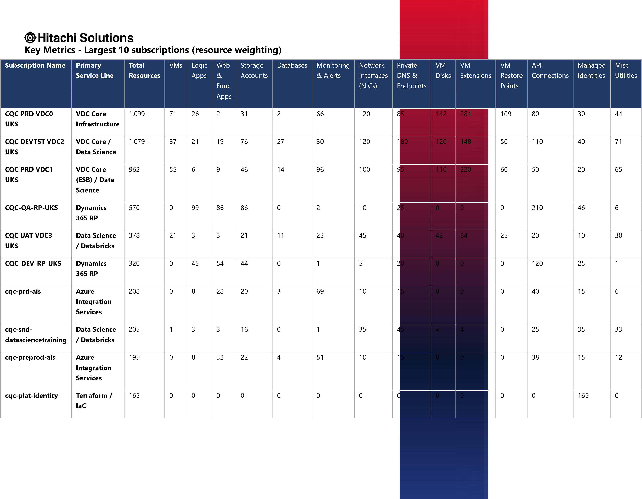

Key Metrics: Subscriptions
Subscription Name | Environment | Resource Count | RG Count | Secure Score (%) | Status (Secure)
cqc-pf-prd | Production | 21 | 2 | 69 | ● Medium
cqc-qa-shared | Production | 4 | 1 | 16 | ● High
sub-caredir-prd-uks-01 | Production | 0 | 0 | 100 | ● Low
sub-datasci-prdb-uks-01 | Production | 32 | 6 | 62 | ● Medium
sub-datasci-prdd-uks-01 | Production | 32 | 6 | 57 | ● Medium
sub-datasci-prde-uks-01 | Production | 32 | 6 | 62 | ● Medium
sub-genai-prdb-uks-01 | Production | 4 | 1 | 100 | ● Low
sub-genai-prdd-uks-01 | Production | 7 | 2 | 100 | ● Low
sub-genai-prde-uks-01 | Production | 4 | 1 | 100 | ● Low
sub-siebel-prd-001 | Production | 14 | 2 | 70 | ● Low
CQC PRD VDC1 UKS | Production (Legacy) | 962 | 58 | 52 | ● Medium
cqc-prd-ais | Production (Legacy) | 208 | 4 | 60 | ● Medium
cqc-preprod-ais | Production (Legacy) | 195 | 4 | 70 | ● Low
CQC-Prod-FinanceProgramme | Production (Legacy) | 107 | 6 | 41 | ● Medium
CQC-Prod-MNSI | Production (Legacy) | 14 | 5 | 54 | ● Medium
sub-caredir-ppd-uks-01 | Pre-Production | 0 | 0 | 100 | ● Low
CQC UAT VDC3 UKS | UAT (Legacy) | 378 | 27 | 56 | ● Medium
sub-caredir-dev-uks-001 | Development | 0 | 0 | 100 | ● Low
sub-hitachi-dev-uks-01 | Development | 8 | 1 | 87 | ● Low
CQC-DEV-RP-UKS | Development (Legacy) | 320 | 11 | 47 | ● Medium
cqc-pf-tst | Test | 21 | 2 | 65 | ● Medium
sub-caredir-tst-uks-01 | Test | 0 | 0 | 100 | ● Low
CQC DEVTST VDC2 UKS | Dev/Test (Legacy) | 1079 | 66 | 63 | ● Medium
cqc-dev-ais | Dev/Test (Legacy) | 164 | 3 | 68 | ● Medium
CQC-Dev-FinanceProgramme | Dev/Test (Legacy) | 91 | 8 | 37 | ● High
CQC-PreProd-FinanceProgramme | Dev/Test (Legacy) | 97 | 8 | 38 | ● High
CQC-Test-FinanceProgramme | Dev/Test (Legacy) | 107 | 8 | 38 | ● High
cqc-tst-ais | Dev/Test (Legacy) | 126 | 4 | 69 | ● Medium
CQC Monitor GFC Dev | GFC (Legacy) | 105 | 11 | 47 | ● Medium
CQC Monitor GFC Test | GFC (Legacy) | 75 | 6 | 44 | ● Medium
CQC Monitor GFC UAT | GFC (Legacy) | 53 | 6 | 53 | ● Medium
CQC PRD VDC0 UKS | Core Infra (Legacy) | 1099 | 80 | 57 | ● Medium
cqc-snd-datasciencetraining | Sandbox | 205 | 15 | 66 | ● Medium
sub-hitachi-poc-uks-01 | Sandbox | 20 | 2 | 54 | ● Medium
cqc-plat-connectivity | Connectivity | 38 | 4 | 51 | ● Medium
sub-connectivity-prd-01 | Connectivity | 18 | 3 | 100 | ● Low
cqc-plat-identity | Identity | 165 | 1 | 14 | ● High
sub-identity-prd-01 | Identity | 17 | 2 | 100 | ● Low
cqc-plat-management | Management | 68 | 3 | 46 | ● Medium
sub-management-prd-01 | Management | 53 | 8 | 59 | ● Medium
sub-security-prd-01 | Security | 17 | 2 | 100 | ● Low
AzurePOC (Converted to EA) | Legacy (Unclassified) | 195 | 28 | 68 | ● Medium
ControlCentre | Legacy (Unclassified) | 0 | 0 | N/A
CQC Eng SharedResources Dev | Legacy (Unclassified) | 83 | 20 | 45 | ● Medium
CQC Eng SharedResources Prod | Legacy (Unclassified) | 81 | 16 | 48 | ● Medium
CQC Intelligence Data Science | Legacy (Unclassified) | 1 | 1 | 25 | ● High
CQC Monitor GFC Prod | Legacy (Unclassified) | 106 | 9 | 47 | ● Medium
CQC-Dev-AssessmentShared | Legacy (Unclassified) | 4 | 2 | 50 | ● Medium
CQC-Dev-AssessmentTool | Legacy (Unclassified) | 12 | 2 | 44 | ● Medium
CQC-INTEGRATIONSERVICES-DEV-UKS | Legacy (Unclassified) | 158 | 18 | 64 | ● Medium
CQC-INTEGRATIONSERVICES-PREPROD-UKS | Legacy (Unclassified) | 0 | 0 | 11 | ● High
CQC-INTEGRATIONSERVICES-PROD-UKS | Legacy (Unclassified) | 103 | 20 | 72 | ● Low
CQC-INTEGRATIONSERVICES-UAT-UKS | Legacy (Unclassified) | 59 | 13 | 50 | ● Medium
CQC-PREPROD-RP-UKS | Legacy (Unclassified) | 194 | 7 | 44 | ● Medium
CQC-PROD-RP-UKS | Legacy (Unclassified) | 137 | 4 | 44 | ● Medium
CQC-QA-ENG-UKS | Legacy (Unclassified) | 3 | 2 | 22 | ● High
CQC-QA-RP-UKS | Legacy (Unclassified) | 570 | 16 | 44 | ● Medium
CQC-Sandbox-ArtificialIntelligence | Legacy (Unclassified) | 14 | 3 | 24 | ● High
MHA SOAD Portal (Converted to EA) | Legacy (Unclassified) | 145 | 23 | 52 | ● Medium
Visual Studio Enterprise Subscription DG | Legacy (Unclassified) | 0 | 0 | 20 | ● High
sub-bootstrap-dev-01 | Root (Bootstrap) | 0 | 0 | 100 | ● Low
sub-bootstrap-prd-01 | Root (Bootstrap) | 14 | 4 | 100 | ● Low
cqc-pf-prd | Decommissioned | 0 | 0 | N/A
cqc-pf-tst | Decommissioned | 0 | 0 | N/A
sub-caredir-dev-uks-01 | Decommissioned | 0 | 0 | N/A

Geographic Distribution
- Primary Region Concentration: The estate is effectively single-region, with 86.1% of resources (6,749) concentrated in UK South. Whilst this aligns with UK data-residency requirements and simplifies policy targeting, the heavy reliance on a single operational heart exposes the organisation to significant availability risk.
- Resilience and Recovery Gaps: A critical resilience gap exists regarding regional failover; whilst
19 of 20 Recovery Services Vaults utilise Geo-Redundant Storage, zero have Cross-Region Restore (CRR) enabled. This prevents the exercise of data recovery during a regional outage, rendering the geo-redundant data inaccessible for immediate recovery.
- Governance Obscurity: 13 resource groups currently span multiple Azure regions. These are the highest-leverage cleanup targets, as multi-region groups weaken regional policy enforcement, complicate disaster recovery planning, and obscure accurate cost attribution.
- Secondary Footprint: A minimal UK West presence of 154 resources (2%) exists, comprising legacy disaster recovery placements and historical deployments. This suggests the secondary region is not currently utilised as a robust or active partner to the UK South baseline.
- Out-of-Region Anomalies: Five resources are currently resident in EU regions (West Europe and North Europe). These are candidates for review and consolidation back into UK South to ensure total alignment with the organisation’s data-residency posture.
- Global Resource Baseline: 1,137 resources (14.5%) are location-agnostic "global" assets, such as DNS zones and classic Application Insights, which provide the underlying framework for the regionalised workloads.

Key Metrics: Overall
Finding | Value | Risk
Resource groups spanning multiple Azure regions | 13 | ● Low
Resources outside UK regions (West Europe / North Europe) | 5 | ● Low
Single-region concentration in UK South | 86% | ● Medium
Recovery Services Vaults with Cross-Region Restore enabled | 0 of 20 | ● High

Key Metrics - Resources by Azure region
Region | Resources | Resource Groups | Share | Notes
uksouth | 6,749 | 514 | 86.1% | Primary region, the operational heart of the estate
global | 1,137 | 203 | 14.5% | Location-agnostic resources (DNS zones, subscriptions, App Insights classic)
ukwest | 154 | 45 | 2.0% | Secondary / DR, small GFC footprint and historical deployments
europe / westeurope | 5 | 5 | 0.1% | Minor, candidate for review and consolidation back to UK South

Workload Distribution
- Estate Balance: The workload is split roughly evenly between IaaS (48.1%) and PaaS (51.6%), with a negligible SaaS footprint (0.3%). Whilst PaaS holds a slight lead in resource count, the estate maintains a dual-mode profile where IaaS dominates compute and networking, while PaaS drives app hosting, monitoring, and data services.
- Distinct Governance Requirements: The two primary domains require tailored management approaches rather than a "one-size-fits-all" bundle. The PaaS surface carries the majority of the policy, identity, and observability burden, whereas the IaaS surface drives the bulk of patching, Network Security Group (NSG), and storage-hardening requirements.
- Compute and Networking Primitives: IaaS remains the foundation for core infrastructure, with 1,713 compute resources (primarily VM extensions and disks) and 1,411 networking resources. This significant IaaS footprint necessitates rigorous maintenance of virtual machine lifecycles and network perimeter security.
- Modernisation Opportunities: Within the compute slice, seven SQL Server instances are currently running on Virtual Machines. These are primary candidates for migration to Azure SQL Database or Managed Instance, which would remove the OS patching and licensing overhead associated with IaaS while aligning with the existing PaaS database footprint.
- App Hosting and Integration: PaaS dominates the application layer with 1,695 resources, heavily weighted toward API Connections and Logic Apps. This indicates a highly integrated ecosystem that relies on managed service providers for messaging and serverless execution.
- Monitoring and Management Overhead: A substantial portion of the PaaS estate (1,575 resources) is dedicated to monitoring and management, including metric alerts and Application Insights. This high volume reflects a mature observability posture but contributes significantly to the overall resource count and management surface.

Key Metrics - Overall
Category | Resources | Share of Estate | Notes
IaaS | 3,789 | 48% | Compute, networking and storage primitives
PaaS | 4,071 | 51.5% | App hosting, monitoring, integration, databases, analytics
SaaS | 22 | 0.5% | Developer subscriptions, Fabric capacities,  Entra B2C
Total | 7,882 | 100% | Active resources across 65 subscriptions

Key Metrics - IaaS breakdown
Subcategory | Count | Share | Dominant resource types
Compute | 1,713 | 21.7% | VM Extensions, VM Disks, Restore Points, VMs, SQL  VMs, VMSS
Networking | 1,411 | 17.9% | NICs, Private Endpoints, Private DNS, NSGs, VNets,  Route Tables
Storage | 665 | 8.4% | Storage Accounts

Key Metrics - PaaS breakdown
Subcategory | Count | Share | Dominant resource types
App Hosting | 1,695 | 21.5% | API Connections (860), Logic Apps Consumption (254), App Service  Plans (206), Function Apps (160), Logic Apps Standard (152), Web  Apps (20)
Monitoring & Mgmt | 1,575 | 20.0% | Metric Alerts (370), Smart Alerts (218), App Insights (206), Activity  Log Alerts (114), Action Groups (105)
Identity & Security | 353 | 4.5% | Managed Identities (234), Key Vaults (118)
Integration &  Messaging | 159 | 2.0% | Event Grid System Topics (141), Service Bus (16), Event Hubs (2)
Databases | 143 | 1.8% | SQL DBs (72), SQL Servers (32), Managed Instance DBs (22),  Cosmos DB (10), Redis (5)
Data & Analytics | 126 | 1.6% | Databricks (21), Data Factories (21), ML Workspaces (14), Cognitive  Services (8), Search (5), Synapse (3)
Backup & Recovery | 20 | 0.3% | Recovery Services Vaults (20), see Backup & Recovery chapter

Key Metric: Workload by Service line
Service Line | Storage | DB | VMs | APIM | Logic | Func | ASP | Total
Core Business Applications | 210 | 10 | 9 | 0 | 177 | 72 | 86 | 564
Regulatory Platform | 5 | 0 | 0 | 0 | 0 | 0 | 0 | 5
Data and Analytics | 56 | 4 | 3 | 0 | 5 | 7 | 17 | 92
Integration Services | 98 | 12 | 28 | 7 | 0 | 43 | 60 | 248
Finance and Corporate | 72 | 3 | 0 | 0 | 0 | 7 | 11 | 93
Identity and Security | 3 | 0 | 17 | 0 | 0 | 0 | 0 | 20
Core Platform | 158 | 65 | 75 | 4 | 55 | 8 | 16 | 381
DevOps and Automation | 6 | 0 | 7 | 1 | 0 | 3 | 3 | 20
End-User Computing | 0 | 0 | 35 | 0 | 0 | 0 | 0 | 35
Monitoring and Observability | 5 | 0 | 8 | 0 | 0 | 4 | 5 | 22
Proof of Concept | 22 | 10 | 0 | 0 | 1 | 0 | 1 | 34
Untagged / Other | 29 | 35 | 5 | 0 | 6 | 1 | 8 | 84
TOTAL | 664 | 139 | 187 | 12 | 244 | 145 | 207 | 1,598

Observations - Tagging
- Standardisation Gap: Tagging is the primary governance failure. Whilst resources average 7.4 tags each, the specific keys required for FinOps and data classification are missing, preventing the use of automated governance controls.
- Non-Canonical Key Usage: The estate uses non-standard keys such as IT-Service-Owner, CostCode, and Data-Classification (with a hyphen). These must be renamed to canonical versions (e.g. Owner, CostCenter) before policy enforcement can be enabled.
- FinOps and Compliance Blindness: Coverage for CostCenter and DataClassification is currently 0%. This makes it impossible to accurately allocate costs or audit data sensitivity at the platform level.
- Environment Value Inconsistency: Although 87.3% of resources have an Environment tag, the values are inconsistent (e.g. PRD, prd, prod, POC, SND). This fragmentation prevents reliable filtering in Cost Management and Azure Policy.
- High-Value Custom Tags: Existing tags that provide operational value, such as BusinessCriticality and IT-Service-Name, should be retained and added to the official schema to assist with incident triage.

Key Metrics - Tag Keys and Values
Grouping | Tag Key | Unique Values
Environment &  Lifecycle | Environment | SND, PRD, DEV, dev, PPD, TST, UAT, snd, Development, test, Dev, prd, prod, POC, MSP, Production, (blank), QA, Pre-  Production, preprod
Environment &  Lifecycle | environment (variant key) | snd, prd, PRD
FinOps | Cost-Code | BAU, POC, Reg Tx, (blank), TBC, Service Delivery Manager Infrastructure & Business Systems, Unknown, tbc, AIS, DS-  Chatbot, Data Science, Finance System, <Configuration>, Engineering, RegTx, Tbc, Tb, DSDBWPOC
FinOps | cost-Code (variant key) | BAU
FinOps | Cost-Centre-Code | (blank), Reg Tx
FinOps | cost_center (variant key) | BAU
Ownership &  Accountability | IT-Service-Owner | DL-CloudPlatformteam@cqc.org.uk, Stuart.H***@cqc.org.uk, Sarah.B***@cqc.org.uk, Alastair.T***@cqc.org.uk, justin.j***@cqc.org.uk, Platform.Management@cqc.org.uk, devops.team@cqc.org.uk, Wamiq.A***@cqc.org.uk, littlefish@cqc.org.uk, Mark.S***@cqc.org.uk, Jatinder.S***@cqc.org.uk, Mark Sharpe, Michael.D***@cqc.org.uk, alastair.t***@cqc.org.uk, PlatformEngineering@cqc.org.uk, Helen.W***@cqc.org.uk, (blank),  Rodney.S***@cqc.org.uk, angelico.f***@cqc.org.uk, Reuben.B***@cqc.org.uk, Mohamedimran.N***@cqc.org.uk, Mohammed Imran Noorgat, Samuel.A***@cqc.org.uk, Anthony.O***@cqc.org.uk, wamiq.a***@cqc.org.uk, ian.h***@cqc.org.uk, Littlefish-Inf, Will.A***@cqc.org.uk, Darren.F***@cqc.org.uk, TBC, taryn.c***@cqc.org.uk,  David.A***@cqc.org.uk, Angelico.F***@cqc.org.uk, Robert.H***@cqc.org.uk, Kehinde.B***@cqc.org.uk,  David.G***@cqc.org.uk, jack.h***@cqc.org.uk, Littlefish@cqc.org.uk
Ownership &  Accountability | iT-Service-Owner  (variant key) | angelico.f***@cqc.org.uk
Ownership &  Accountability | Created-By | stuart.h***@cqc.org.uk, SubscriptionAutomationV2, aakash.e***@cqc.org.uk, (blank), justin.j***@cqc.org.uk, littlefish@cqc.org.uk, Simon.S***@cqc.org.uk, Wamiq.A***@cqc.org.uk, Mark.S***@cqc.org.uk, devops.team@cqc.org.uk, Jarrod.C***@cqc.org.uk, Bethan Vaughan, Saadia.S***@cqc.org.uk,  Mohamedimran.N***@cqc.org.uk, Platform.E***@cqc.org.uk, Stefan.S***@cqc.org.uk, paul.c***@cqc.org.uk,  Aakash.E***@cqc.org.uk, wamiq.a***@cqc.org.uk, bethan.v***@cqc.org.uk, TBC, DevOps Pipeline,  Bethan.V***@cqc.org.uk, Subscription Automation, Stefan Syrett, Michael.D***@cqc.org.uk, Anthony.O***@cqc.org.uk, Angelico.F***@cqc.org.uk, Littlefish-Inf, Robert.H***@cqc.org.uk, Sam, tayo.a***@cqc.org.uk, Mark.H***@cqc.org.uk

Ownership &  Accountability | CreatedBy (variant key) | Jarrod Clancy, Alastair.T***@cqc.org.uk
Ownership &  Accountability | Created By (variant key) | Sean Wasonga
Ownership &  Accountability | createdBy (variant key) | Sentinel
Ownership &  Accountability | CreatorUPN | sean Wasonga
Ownership &  Accountability | Owner | tim.d***@cqc.org.uk
Ownership &  Accountability | Service-Owner | Rodney Stuart, Ragavendran Balachandran, DevOps
Ownership &  Accountability | Application-Owner | Finance programme, Alastair.T***@cqc.org.uk, (blank)
Application &  Workload | IT-Service-Name | SubscriptionVendingTest, GenAI, PLZ Identity, Hitachi Rebuild, PLZ Security, DataScience, t1, Terraform Backend - 'assessmentshared', AzureUpdateManager, Platform Management, Subscription Automation, cloud consumption data, Azure Cloud, FTP, Dynamics 365, RP-EDP Integration, (blank), DevOps Pipeline, Provider Portal, B2C Login,  DMA, finance-dl, apim, Infection-control, direct-monitoring, apim-vnet, Direct Monitoring, Enterprise Service Bus  (ESB), GFC Service, VDC3-CoreInfra, TMA - Transition Monitoring App, vdc3, tdi, AltiusPOC, SQL Server,  ServiceNowMIDServers, WEB Server, Self Hosted Agent, Azure Integration Services (AIS), VDC0-CoreInfra, sqldb, chatbot, lfpse, mlopstraining, amltraining, Terraform Backend - 'datasciencetraining', Data Science Training,  Enterprise Data Platform, rg-prod-ais-01, la-prod-uks-ais-esrfilecopy-01, Platform Connectivity, AIS, la-prod-uks-aisesr-sync-01, la-prod-uks-ais-ols-01, la-prod-uks-ais-gfc-01, la-prod-uks-ais-esr-mapping-lookups-01, rg-test-ais01, la-test-uks-ais-esrfilecopy-02, la-test-uks-ais-gfc-01, la-test-uks-ais-esrfilecopy-01, la-test-uks-ais-esr-sync-01, aidsedp, Dynamics Finance and Operations, Finance and Operations, Provider Location Search, File Upload, Give Feedback on Care, GFC, Secret Management, ServiceDefinition, Infection Prevention Control, Azure DevOps  Pipelines, vdc1, Datascience Adult Scoial Care Temp, RDS-RemoteAccess Gateway Manager, VDC1-CoreInfra, RDSRemoteAccess Session Host Servers - Infosys, ER/Studio, RDS-RemoteAccess Session Host Servers - Avanade, Power  BI Gateway, Leaver Automation, RDS-RemoteAccess Connection Broker, RDS Remote Access, RDS-RemoteAccess  Session Host Servers - KPMG-AIS, DevOps Agent, Pingo Services, IBM SPSS Licence, Print Services, RDS-  RemoteAccess Session Host Servers - KPMG, SOAD and MHA Complaints, automation account, <Configuration>,  SOAD, Siebel Archival project PoC, appinsights-vdc1-prd, RDS-RemoteAccess File Server, Database for sharepoint  Prod, Legacy Provider Portal Archive - Decommission, MHA Complaints, PeopleFinderCore, KingswaySoft  Integration Toolkit Dynamics 365, SQL Managed Instance for Prod, Connectivity, IPAM, ddos, Azure Platform,  Application Registration Vending, PLZ Management, EDP, PLZ Connectivity, PLZ Bootstrap, vdc2, rg-dev-ais-01,  VDC2-CoreInfra, dsedp, Database for .net test app, ESB Service Bus, Power BI, Histroic Report, GL3 E2E Data  Migration, DocMigrationFilesharetoSPDev, Document Migration from Azure to SP, Peoplefinder, TDI, Automation, Finance, Database for .net app, Azure DevOps, Test automation, Test Automation, web, sftp, rds-hscnsh, spss, rdsremoteaccess, exchange, remotedesktopservices, pingo, ServiceNow, smtpgw, genai-infrastructure, financeinfrastructure, ipam, soad, mha-soad-portal, tma, Give Feedback On Care, pmpc, rp-infrastructure, Azure Update Manager, mabs, datascience-infrastructure, caredir-infrastructure, sql, intune-connector-active-directory, jml, sha, siebel-dr-migrate, powerbigateway, app-vending, automation, nps, entraappproxy, pf-infrastructure, dns, resourcegraph-queries, print, qa-shared-infrastructure, adcs, erstudio, proof-of-concept, private-dns-zone-infrastructure, databricks-poc, msp-corp, Platform Identity, ais-infrastructure, avs, Siebel, AVS, Virtual Network, RDS/SessionHost, DNS, Active Directory Certificate Services (AD CS), IvantiConnectSecure, MSP OS Update Ring, SMTP Gateway,  MDaemon POP Relay, NPS, AD, Azure AD Connect, JML Automation, HSCN Proxy, PMPC, Intune Connector Active  Directory, Remote Desktop Services, FileServer, SOAD Portal, Exchange Management, avs jumpbox, Entra App Proxy,  CRM - Production, On-Prem Data Gateway, Microsoft Azure Backup Server, AzureAdvisor, Covid 19 Enquiry, Virtual Machine Management, Multiple, devopssmkv, Certificate, Mental Health Apps, SOAD MHA Portal, SOADPortal, logic-ManualFeeCalculation-UAT, Fee, rg-preprod-ais-01, la-preprod-uks-ais-cacheengine-01, sapreproduksaiscachela01
Application &  Workload | iT-Service-Name (variant key) | amltraining
Application &  Workload | Application-Name | iHubV2, apim-vnet, vdc1, Data Warehouse, Finance programme, (blank), SiebelLanding, Azure B2C Custom Policy

Application &  Workload | Service-Name | GL3 E2E Data Migration, SQL server, Siebel Decommission Migration, Dynamics 365
Application &  Workload | IT-Service-Function | CQC DevOps
Application &  Workload | Function-Role | core, Resource group, Transformed Data
Application &  Workload | Project | Historic Reports, EDP
Application &  Workload | application | databricks
Application &  Workload | workload | plz
Compliance &  Security | Business-Criticality | Tier 1, Tier 3, Tier 2, Business-Important, Non-Critical, Tier 4, missioncritical, Low, TBC
Compliance &  Security | business-Criticality  (variant key) | Tier 3
Compliance &  Security | Business Critically (typo key) | AIS, Non-Critical
Compliance &  Security | Business-critically (typo key) | TBC, Business-Important
Compliance &  Security | Business-Critically (typo key) | Low, Business-Important
Compliance &  Security | Data-Classification | Confidential, General, secret, (blank), TBC, test, String, TBC by Security Team
Compliance &  Security | data_classification  (variant key) | Internal
Compliance &  Security | Department | (blank), Digital
Compliance &  Security | Directorate | (blank), TBC, CQCIT
Operations &  Scheduling | Managed-By | Terraform, LittlefishTerraform, CQCTerraform
Operations &  Scheduling | ManagedBy (variant key) | Terraform
Operations &  Scheduling | Schedule-Startup | None, (blank), 20 7 * * *, 0 7 * * *, TBC, 0 6 * * *, 0 8 * * *, 40 7 * * *, N/A, na, False
Operations &  Scheduling | Schedule-Shutdown | TBC, None, (blank), na, False, 6PM -> 6AM, Saturday, Sunday
Operations &  Scheduling | Update | True, False
Operations &  Scheduling | Update-Day | Tuesday, (blank), Thursday, TBC, NA, Friday
Operations &  Scheduling | Update-Week | 4, (blank), 1, 3, NA, 2
Operations &  Scheduling | Update-Window | Default, Webserver, Default-Delay, Default-Thursday, Default-Offset0, HSCN, Default-Offset2

Operations &  Scheduling | Update-Environment | MSP
Operations &  Scheduling | Update-Action | Start, StartStop
Operations &  Scheduling | Backup | True, False
Operations &  Scheduling | Backup-Window | Default
Operations &  Scheduling | Backup-Time | (blank), 18:00
Provenance &  Lifecycle | ExpirationDate | (blank), TBC
Provenance &  Lifecycle | managed_by_terraform | TRUE
Provenance &  Lifecycle | databricks-environment | TRUE
Provenance &  Lifecycle | managed_by | packer
Provenance &  Lifecycle | Creation-Date | 13/02/2023, 28/04/2023, 09/07/2025, 15/07/2025, 16/07/2025, 14/07/2025, 26/06/2025, 23/07/2025, 25/06/2025
Provenance &  Lifecycle | created-Date (variant key) | N/A
Provenance &  Lifecycle | ADO-Repository | give-feedback-on-care
Cloud Operations  / Tooling | ftk-tool | FinOps hubs, FinOps workbooks
Cloud Operations  / Tooling | ftk-version | 0.8
Cloud Operations  / Tooling | cm-resource-parent | REDACTED-RESOURCE-ID (2 values)
Cloud Operations  / Tooling | Module | azurerm_search_service
Cloud Operations  / Platform | SubscriptionName | CQC-INTEGRATIONSERVICES-DEV-UKS, CQC-INTEGRATIONSERVICES-UAT-UKS
Cloud Operations  / Platform | Location | uksouth
Cloud Operations  / Platform | Name | vnet-dev-rp-uks-01, sauatukshistrpt, starchivedbacpacstoreprd, saprdukshistrpt, sqlsvr-crmarchive-prd, stcrmdocprd, sqldb-crmarchive-prd, saprduksprovportalarch, aag-devtst-003-policy-01, aag-prd-crm-001-policy, sasitukshistrpt, sadevtstukshistrptjson, stcrmdocdev, cqc-qa-eng-uks-keyvault, kvukspbianalytics, kv-devops-sm-01, vnet-qa-rp-uks-01
Security /  Sentinel  (hidden/system) | hidden-  SentinelTemplateVersio n | 1.0, 1.1
Security /  Sentinel  (hidden/system) | hidden-  SentinelTemplateName | DailyThreatExposureReport-Copilot, Reset-AADUserPassword, CreateSNOWRecord-Alert, CreateSNOWRecord-  Incident
Monitoring  (hidden/system) | hidden-title | appins-prod-uks-ais-01 Dashboard, CQC - Resources, DocMigrationFilesharetoSPDev202304140641 Dashboard, VM Performance Report 1, CQC Indicators Resources, appinsights-peoplefinder-uks-devtst Dashboard, Sam DS Test,  CQCSharedDocumentUpload-Dev Dashboard, Littlefish | Patch Management, Storage Account Overview Dashboard, GenerateFilesPowerShellScripts Dashboard, Api-Management Dashboard, Globalscape SFTP Dashboard, webtestsystem-availability Dashboard, SharePoint Dashboard, ETL_Status_Prod, CQC Monitoring Dashboard, appinsightsvdc1-prd Dashboard, SD-AdultSocialCare Dashboard, prod-func-rp-manualfeescalcv2 Dashboard, Security Operations Efficiency - soc-vdc0-hub-uks, Littlefish | Workbook, CQC, Sign-ins using Legacy Authentication,  Littlefish | Orphan Resource Monitoring, SOC_EF - Backup Copy, Microsoft Web Application Firewall (WAF) - firewall events - soc-vdc0-hub-uks, Workspace Usage Report - soc-vdc0-hub-uks, FortiGate - soc-vdc0-hub-uks, Littlefish | Backup Monitoring, LT- Linux Patch Status, Security Incidents By SOC, Microsoft Sentinel Cost - soc-vdc0-hub-uks,  Littlefish Overview, Littlefish | AMA Health, Office 365 - soc-vdc0-hub-uks, Security Operations Efficiency - Custom 7  Days (F), Azure AD Audit logs - soc-vdc0-hub-uks, Security Alerts, LT - Windows Update Compliance, Domain  Controllers, Exchange Online - soc-vdc0-hub-uks, Azure AD Sign-in logs - soc-vdc0-hub-uks, MITRE ATT&CK Workbook - soc-vdc0-hub-uks, AIS-Security-Overview, Azure AD Audit, Activity and Sign-in logs - soc-vdc0-hubuks, Littlefish | Service Retirement, Incident Overview, Security Operations Efficiency - Custom 30 Days, Littlefish | Cost Optimization (Preview), Monthly Azure Cost Report, (Dev) Registrations App Detailed Logs, ETL_Status_UAT, Azure Costs - Dev, FinOps - Governance, GFC, FinOps - Optimization, AIS Service Health Dashboard, gfc-categorymapping Dashboard, Azure Costs - Finance, Azure Costs (BAU), Azure Costs - AIS, Azure Security Scores, Azure  Costs - Regulatory Platform, Azure Costs - EDP, Azure Costs, MHAPORTAL-TEST-APP-INSIGHT Dashboard,  MHAPORTAL-PROD-APP-INSIGHT Dashboard, MHAPORTAL-DEV-APP-INSIGHT Dashboard, Fees UAT Performance -  Function Apps, uat-func-rp-manualfeescalc Dashboard, DM-func-rp-buildinvoicessharepointfile Dashboard, Fees  UAT Performance - Logic Apps, Fees Monitoring, uat-func-rp-buildinvoicessharepointfile Dashboard
Other / Hygiene | To delete | This is just a test so will need to delete
Other / Metadata | identifier | (blank)
Other / Metadata | Networking | Disabled
Other / Metadata | Description | This identity is used to create and manage Azure DevOps resources in Terraform. Do not delete.

Key Metrics: Tag usage, top 15
# | Tag Key | Resources (Coverage) | Unique Values | Subscriptions | Canonical?
1 | Environment | 7,213 of 7,839 (92.0%) | 20 | 57 | Yes
2 | IT-Service-Name | 7,193 of 7,839 (91.8%) | 217 | 57 | No (non-canonical)
3 | Cost-Code | 7,192 of 7,839 (91.7%) | 18 | 57 | No (should be CostCenter)
4 | IT-Service-Owner | 7,128 of 7,839 (90.9%) | 38 | 57 | No (should be Owner)
5 | Created-By | 6,923 of 7,839 (88.3%) | 33 | 50 | No
6 | Business-Criticality | 6,883 of 7,839 (87.8%) | 9 | 57 | No (high-value custom)
7 | Data-Classification | 4,274 of 7,839 (54.5%) | 8 | 36 | No (should be DataClassification)
8 | Managed-By | 618 of 7,839 (7.9%) | 3 | 11 | No
9 | Schedule-Startup | 550 of 7,839 (7.0%) | 11 | 11 | No (operational)
10 | Schedule-Shutdown | 539 of 7,839 (6.9%) | 6 | 12 | No (operational)
11 | Update | 272 of 7,839 (3.5%) | 2 | 7 | No
12 | Update-Window | 267 of 7,839 (3.4%) | 7 | 7 | No
13 | Backup | 260 of 7,839 (3.3%) | 2 | 7 | No
14 | Backup-Window | 253 of 7,839 (3.2%) | 1 | 7 | No
15 | Update-Day | 245 of 7,839 (3.1%) | 6 | 16 | No

Key Metrics - Tag Coverage by Service Workload
Workload | Total | IT-ServiceName tag present | Coverage %
Storage | 665 | 628 | 94.4%
Database | 80 | 78 | 97.5%
Virtual Machines | 194 | 0 | 0.0%
APIM | 12 | 0 | 0.0%
Logic Apps | 406 | 0 | 0.0%
Function Apps | 161 | 0 | 0.0%
App Service Plans | 206 | 196 | 95.1%

Observations - Policy
The framework is structurally sound, but its effective coverage is held back by a few denyaction gates failing across the legacy estate. Assignments sit predominantly at management-group scope, and the standard Azure Landing Zone guardrail initiatives (the seven Enforce-GR-* set covering storage, key vault, network, compute, automation and CMK encryption) are assigned at the platform branch. The problem is not the design; it is the concentration of non-compliance in storage and logging controls on subscriptions not yet under the CAF-aligned hierarchy.
- The headline compliance figure is misleading. It is weighted by audit-only policies that block nothing. The handful of deny gates that actually matter sit far lower.
- Four policies drive the breach count: secure transfer not enforced (514 storage accounts), TLS below 1.2 (368), network access not restricted (135), and Key Vault logs disabled (168 vaults).
- The breaches sit on the legacy branches. Compliance on the legacy and interim hierarchies is well below the target CQC hierarchy, and the storage failures alone span 39 subscriptions.
- Top four policies being breached: These four policies account for 1,185 of the 1,529 criticalimpact breaches across the estate (77.5%). The remaining 22 critical-deny policies, taken together, account for 344 breaches and most sit above 80% compliance. These policies assignments appear to have been removed during the duration of this assessment.

Where the breaches concentrate
- Storage accounts dominate. Three of the four top-breach policies target storage. Combined with the next-tier storage policies (public access disallowed at 80.7%, shared-key access controls), the storage tier is the single largest source of critical non-compliance in the estate.
- 39 subscriptions carry the storage breaches. Three of the four policies have identical subscription coverage (39 subscriptions, 663 evaluated accounts), consistent with the same initiative deployed across the legacy and pre-platform branches. The full per-subscription league table needs an Azure Policy console pull. The data confirms the breaches are not isolated to one or two subscriptions; they are estate-wide on the legacy footprint.
- The Key Vault logging breach is broader, lower density. 168 non-compliant Key Vault resources across 53 subscriptions. Wider footprint than the storage breaches but each subscription carries fewer affected resources. This is the diagnostic-settings gap referenced in the Defender chapter.

Key Metric - Policy Compliance
MG | Policy compliance | Risk
CQC | 90% | ● Low
Mg-cqc-legacy | 52% | ● High
Mg-cqc-root | 54% | ● High
Mg-decommision | 100% | N/A

Key Metric – Top 4 policies being breached
Policy | Compliance | Non-Compliant | Subscriptions | Risk
Secure transfer to storage accounts should be enabled | 19.5% | 514 of 663 | 39 | ● High
Storage accounts should have the specified minimum  TLS version | 41.3% | 368 of 663 | 39 | ● High
Resource logs in Key Vault should be enabled | 87.5% | 168 of 7,665 | 53 | ● High
Storage accounts should restrict network access | 23.6% | 135 of 178 | 8 | ● High

Security: Defender for Cloud

Observations
Defender for Cloud is enabled on 61 of 65 subscriptions, but its outputs cannot be acted upon at scale. Mean Secure Score across the enabled estate is 59.8% against a 75% target, the active backlog stands at 4,870 Critical and High recommendations (323 Critical, 4,547 High), and 100% of the 1,461 inspected resources have no diagnostic settings configured. The Defender data plane is producing signal that the SOC has no path to consume.

Microsoft Defender for Cloud is the principal source of continuous security posture management signal. The current state across the CQC tenant:
- 4 subscriptions have Defender for Cloud Disabled entirely - they report a 0% Secure Score: `cqc-pf-prd`, `cqc-pf-tst`, and two others. These must be enabled as the first remediation step, because without Defender enabled the rest of the Secure Score is meaningless.
- 43 subscriptions have a Low Secure Score (below 60%). Of those, the lowest tenanted score is `cqc-plat-identity` at 14% - striking because this is the identity subscription and therefore the most security-sensitive one in the estate.
- 2,246 High-severity recommendations are outstanding across the tenant. The top three by frequency are:

Key Metrics: Coverage & Secure Score
Metric | Value | Risk
Subscriptions evaluated | 65 | ● Low
Defender for Cloud disabled | 4 | ● High
Subscriptions below 60% Secure Score | 35 | ● High
Mean Secure Score (enabled estate) | 59.8% | ● Medium
Median Secure Score | 56.3% | ● Medium
Lowest score (CQC-  INTEGRATIONSERVICES-PREPROD-UKS) | 11.0% | ● High
cqc-plat-identity (central identity) | 14.2% | ● High
Subscriptions at 100% (new CAF builds) | 12 | -

Security: Network

Objective
Ensure secure network segmentation & private connectivity across workloads.
- Assess VNet & subnet design (hub/spoke, isolation, NSG coverage).
- Evaluate private endpoint coverage & peering topology.
- Identify governance bypass risks (isolated VNets without central controls).

Workloads in Scope
- Virtual Networks / Subnets / NSGs
- VNet Peering
- Private Endpoints

Observations - Network Segmentation
- Legacy Topology (Non-Target State): The current Azure estate exhibits a hybrid
“hub-and-spoke plus direct peering” topology that has evolved iteratively over time. While a central hub VNET exists and most peerings are operationally connected, the resulting structure is best characterised as a legacy transition state rather than a mature or target architecture. This condition is acknowledged by the platform team and is not intended to be remediated in place.
- Hub VNET NSG Coverage (Known Legacy Risk): The production hub VNET demonstrates incomplete NSG coverage across its subnets. This is a recognised legacy condition resulting from historic deployment patterns, not an intentional design choice. The associated lateral-movement risk is understood and accepted as part of the current estate, with the explicit mitigation being prevention through policy in the CAF-aligned environment rather than retroactive correction.
- Spoke VNET Segmentation Patterns: A subset of application and data spokes demonstrates full NSG coverage and consistent segmentation, reflecting patterns that align with the intended future state. However, these are exceptions rather than the norm in the legacy estate and should be viewed as illustrative templates rather than evidence of estate-wide compliance.
- Unprotected and Partially Protected Spokes: Multiple spoke VNETs operate with limited or absent NSG protection. Where hub-connected, these increase theoretical lateral movement risk; where isolated, they represent contained but unmanaged security domains. These conditions are acknowledged and will be structurally prevented in the target architecture through mandatory NSG enforcement at subnet creation.
- Isolated VNETs Outside Central Governance: Several isolated VNETs operate outside the centrally governed hub topology, including service-specific and sandbox environments. These reflect historic deployment autonomy and transitional use cases. The remediation strategy for these environments is consolidation, retirement, or formal exception under the CAF-aligned management group structure, rather than universal re-engineering.
- Sandbox and Proof-of-Concept Drift: Sandbox and proof-of-concept VNETs persist beyond their intended lifespan with minimal network controls. This pattern is recognised as a governance gap. In the target environment, sandbox deployments will be time-bound, auto-decommissioned, or fully isolated by policy to prevent uncontrolled drift.
- Peering Hygiene: A small number of disconnected peerings remain present in the estate. While low risk, these contribute to operational ambiguity and should be removed opportunistically as associated workloads are retired.

CoreInfrastructure (CQC PRD VDC0 UKS)
└── vnet-hub-uks-prd [Hub 20 subnets 35% subnet NSG coverage]
├── Production spokes:
│ ├── vnet-spoke-ims-apps-uks-prd (IMS production apps)
│ ├── vnet-spoke-tdi-data-uks-prd (Production data plane)
│ ├── vnet-spoke-tdi-data-uks-sharedprd (Shared production data)
│ ├── vnet-spoke-cqc-apps-uks-prd (CQC application VNet)
│ └── vnet-avsnet-prd-uks-01 (AVS / Siebel, transitional)
├── UAT / pre-prod spokes:
│ ├── vnet-spoke-ims-apps-uks-uat
│ ├── vnet-spoke-tdi-data-uks-uat
│ ├── vnet-ppd-rp-uks-01 (Pre-prod Registration)
│ └── vnet-qa-rp-uks-01 (QA Registration)
├── Dev / test spokes:
│ ├── vnet-spoke-ims-apps-uks-devtst
│ ├── vnet-spoke-tdi-data-uks-dev/test/shareddev
│ └── vnet-spoke-datasci-prdb/prdd/prde-uks-01
└── Hub-attached connectivity:
├── vnet-spoke-vpnuser-uks (User VPN)
├── vnet-spoke-ims-apps-uks-vpndevice (Device VPN)
├── vnet-spoke-longarm-uks-prd-s2s (Site-to-site)
└── vnet-uks-hscn (HSCN connectivity)
Isolated / unconnected VNets (governance bypass risk):
, GFC-APP-VNET / GFC-DEV-GW-vnet / GFC-TEST-GW-vnet / GFC-APP-UAT-VNET
, vnet-Dev-DocMigrationFilesharetoSPDev-UKS-01
, vnet-gds-poc-uks-01, vnet-poc-la-uks-01 (AzurePOC)
, vnet-spoke-ims-dev-uks-assessmenttool
, MHAPortal, vnet-dev-soad-uks-portal
, appgwvnet (CQC-INTEGRATIONSERVICES-DEV-UKS)

Hub & Spoke Network Topology
Metric | Value | Target | Risk | Comment
VNets (total) | 76 |  |  | Scope indicator across all subscriptions.
Hub VNets | 6 | 1 - 2 | ● Medium | 6 hubs detected - verify each is intentional and not a misconfigured spoke.
Isolated VNets (no peering) | 34 | 0 | ● Medium | Confirm whether these are intentional islands or unmanaged/bypass deployments
Fully NSG-protected  VNets | 16 / 76 | 100% | ● High | Coverage is low. Exclude platform subnets  (GatewaySubnet, AzureFirewallSubnet, AzureBastionSubnet) before remediating, as these do not accept a standard NSG.
Average NSG coverage | 32% | 100% | ● High | Most workload subnets have no NSG attached. Apply a baseline ruleset across all workload subnets.
VNets with Custom  DNS | 17 / 76 | 100% | ● Low | 59 VNets use Azure default DNS - no private DNS resolution or on-prem integration.
Connected peerings | 98 / 99 | 99 100% | ● Low | Peering mesh is healthy - 1 disconnected peering requires investigation.
Disconnected peerings | 1 | 0 | ● Low | Low risk but should be resolved to avoid stale routing entries.
Azure Firewall instances | 4 (all  Standard) | Premium  (egress) | ● Medium | Standard SKU lacks IDPS and TLS inspection - upgrade to Premium for full egress control.
VPN Gateways | 6 |  |  | Scope indicator - validate each aligns to an active on-prem/branch connection.

Key Observations:
- Six hubs. Multiple connectivity centres, not one. Confirm intent per hub.
- 34 isolated VNets (47%). Likely orphaned. Confirm each as deliberate or remove.
- NSG coverage 21% full, 32% average. Most workload subnets unprotected. Exclude platform subnets (GatewaySubnet, AzureFirewallSubnet, AzureBastionSubnet) before remediating.
- All 4 firewalls Standard tier. No IDPS or TLS inspection. Review against CQC compliance.

Key Metrics: Hub VNets
Subscription | Branch | VNet Name | Subnets | NSG  Cov | Function | Risk | Comment
CQC PRD VDC0  UKS | mg-cqclegacy | vnet-hubuks-prd | 20 | 35% | Hub /  transit | ● High | Production transit hub (36 peerings). Low NSG coverage leaves spoke to hub traffic uninspected. Exclude platform subnets before treating 35% as the gap.
CQC PRD VDC0  UKS | mg-cqclegacy | vnet-ukshscn | 7 | 0% | General workload | ● High | NHS data path with no NSG. Direct compliance risk under DSP Toolkit and HSCN agreement.
CQC PRD VDC0  UKS | mg-cqclegacy | vnet-spokelongarmuks-prd-s2s | 2 | 0% | General workload | ● High | On premises traffic enters with no filtering at the VNet edge.
CQC PRD VDC0  UKS | mg-cqclegacy | vnet-spokeims-appsuksvpndevice | 3 | 0% | VPN /  Gateway | ● High | VPN termination with no NSG. Confirm count excludes the GatewaySubnet.
CQC PRD VDC0  UKS | mg-cqclegacy | vnet-spokeims-appsuksvpnuser-b | 3 | 0% | VPN /  Gateway | ● High | User VPN entry, unfiltered. Compromised account reaches hub resources directly.
CQC PRD VDC0  UKS | mg-cqclegacy | vnet-spokevpnuser-uks | 2 | 0% | VPN /  Gateway | ● High | Third VPN entry with no subnet filtering.

Key Metrics: NSG Summary
Metric | Value | Target | RAG | Comment
Total inbound Allow rules evaluated | 312
NSGs in scope | 106
Flagged rules (Flag = "F") | 79 |  | ● Medium | 25.3 % of rules are permissive - acceptable range but trend monitor needed.
NSGs containing ≥ 1 flagged rule | 42 |  | ● Medium | 39.6 % of NSGs have findings - ownership spread across teams.
% of NSGs with findings | 39.6  % | < 10 % | ● Medium | Points to need for NSG hardening policy and review process.
Subscriptions with ≥ 1 Critical finding | 4 | 0 | ● Medium | 19 % of subscriptions have exposure.
Allow Any Inbound (wildcard src + port) | 0 | 0 | ● Low | No full-open rules - good.
Allow RDP from Any (3389 from Internet) | 6 | 0 | ● High | Critical. 6 remote management ports exposed; replace with Bastion/JIT immediately.
Allow SSH from Any (22 from  Internet) | 1 | 0 | ● High | Critical. 1 Linux SSH exposed; replace with Bastion/JIT.
Allow from Any Source (other ports) | 72 | risk-  based | ● Medium | Majority are web/API ports (80, 443, 3306, 5432, etc.) - review if fronted by WAF/LB.

Key Metrics: NSG Findings by category
Finding Category | Count | Subscriptions |  | Risk | Action
Allow from Any Source on port 443 | 32 |  | 13 | ● Medium | Permit only behind  WAF/App Gateway in Prevention mode.
Allow from Any Source (other ports) | 29 |  | 11 | ● Medium | Review and scope source prefixes to trusted ranges/service tags.
Allow from Any Source on port 80 | 11 |  | 5 | ● Medium | Allow only for approved public apps and enforce HTTPS redirect + WAF.
Allow RDP from Any | 6 |  | 3 | ● High | Replace with Azure  Bastion + JIT VM access.
Allow SSH from Any | 1 |  | 1 | ● High | Replace with Azure Bastion + JIT access.

Observations - Private Endpoints
- Overall: 214 private endpoints are deployed across the estate, with 194 approved connections (90.7% success). 20 endpoints have failed connections and fall back to public access.
- Storage accounts dominate the footprint at 110 endpoints (10 failed, 90.9% success) and span 19 subscriptions, making them the largest single source of private link usage.
- Failures are concentrated: 16 of the 20 sit in CQC DEVTST VDC2 UKS, pointing to a single misconfiguration event in that dev/test subscription rather than a systemic problem.
- Production: Two failures are in production (CQC PRD VDC1 UKS on Sql, CQC PRD VDC0 UKS on a malformed type record). These carry real exposure because a failed endpoint reverts the resource to its public path, and warrant priority remediation ahead of the dev/test backlog.
- Web app endpoints are the weakest service after Sql once the case-split records are combined: 10 endpoints, 3 failed, 70% success.

Key Metrics - Private Endpoints by Target Resource Type
Subscription | Branch | Resource Type | Total PEs | Approved | Failed | Success % | Subs | Risk
CQC PRD VDC1  UKS | mg-cqclegacy | SQL Servers | 5 | 4 | 1 | 80.0% | 3 | ● High
CQC PRD VDC0  UKS | mg-cqclegacy | Unknown (malformed type) | 1 | 0 | 1 | 0.0% | 1 | ● High
CQC DEVTST VDC2  UKS | mg-cqclegacy | Storage Accounts | 33 | 23 | 10 | 69.7% | 19 | ● Medium
CQC DEVTST VDC2  UKS | mg-cqclegacy | SQL Servers | 12 | 9 | 3 | 75.0% | 3 | ● Medium
CQC DEVTST VDC2  UKS | mg-cqclegacy | Web and Function Apps | 3 | 1 | 2 | 33.3% | 6 | ● Medium
CQC Monitor GFC  Dev | mg-cqclegacy | Web and Function Apps | 2 | 1 | 1 | 50.0% | 6 | ● Low
cqc-dev-ais | mg-cqclegacy | Automation Accounts | 1 | 0 | 1 | 0.0% | 9 | ● Low
CQC DEVTST VDC2  UKS | mg-cqclegacy | Machine Learning  Workspaces | 1 | 0 | 1 | 0.0% | 5 | ● Low
 |  | All other resource types | 156 | 156 | 0 | 100.0% |  | ● Low

Key Metrics - Failed Private Endpoints by Subscription
Subscription | Branch | Failed | Resource Types Affected | Risk
CQC DEVTST  VDC2 UKS | mg-cqclegacy | 16 | Microsoft.MachineLearningServices/worksp aces, Microsoft.Sql/servers,  Microsoft.Storage/storageAccounts,  Microsoft.Web/Sites, Microsoft.Web/sites | ● High
CQC Monitor GFC  Dev | mg-cqclegacy | 1 | Microsoft.Web/sites | ● Medium
CQC PRD VDC0  UKS | mg-cqclegacy | 1 | / | ● Medium
CQC PRD VDC1  UKS | mg-cqclegacy | 1 | Microsoft.Sql/servers | ● Medium
cqc-dev-ais | mg-cqclegacy | 1 | Microsoft.Automation/automationAccounts | ● Medium

Observations - Network Watcher
Network Watcher is the foundational diagnostic service for Azure networking (NSG flow logs, connection troubleshoot, IP flow verify). The CQC tenant has 43 Network Watcher records; 32 are successfully deployed and 11 are flagged as `NOT DEPLOYED`, meaning those subscription-region combinations have no NSG flow logs or connection diagnostics available.
Metric |  | Value
Network Watcher instances (total) | 43
Successfully deployed (Succeeded) | 32
Not Deployed (Network Watcher missing) | 11

Security: External Exposure

Objective
Identify and minimize external exposure points across all cloud workloads.
- Detect resources with public endpoints or internet-facing interfaces.
- Assess the necessity and security posture of each exposure.
- Recommend remediation to Reduce attack surface and enforce best practices.
- Evaluate exposure of critical resources and compliance with security best practices.

Workloads in Scope
- Public IP Addresses (static and dynamic)
- Un-associated IP addresses (IP's not currently attached to any active resource or service).
- Load Balancers, Application Gateways, Firewalls, VPN/NAT Gateways (publicfacing endpoints)
- App Services, APIs, Logic Apps, Storage Accounts, Databases with public endpoints
- DNS records and publicly resolvable domains
- DDoS protection and network security controls
- Other Azure resources with public endpoints

Observations - Public IP Addresses
- No DDoS Protection: 0 of 40 Public IP addresses are protected by an Azure DDoS Protection Standard plan. For a public-facing regulator, this is a significant resilience gap - the platform has no managed protection against volumetric or protocol-level distributed denial-of-service attacks. While Azure's basic DDoS protection applies at the platform layer, only Standard/Network plans provide per-resource alerting, telemetry, and post-incident reports.
- Standard SKU dominant: 38 of 40 Public IPs are on the Standard SKU - this is the correct posture. Standard SKU is required for Availability Zones, regionredundant load balancing, and the next generation of Azure networking features.
- Legacy Basic SKU: 2 Public IPs remain on the Basic SKU. Basic Public IP retirement was announced by Microsoft - these IPs should be migrated to Standard SKU on a planned schedule before the retirement deadline.
- Orphaned addresses: 1 Public IPs are not associated with any resource. These accrue cost with no operational benefit and should be released.
- Distribution by purpose: Application Gateways (16), VNet Gateways (6), Azure Firewalls (6), and NICs (6) account for the bulk of Public IP allocation. Bastion Hosts (2) and NAT Gateways (3) account for the remainder. The shape of the distribution is operationally sensible.

Key Metrics - Summary
Metric |  | Value |  | Risk
Total Public IPs | 40
DDoS Network Protection (Standard) enabled | 0 |  | ● High
Standard SKU | 38 |  | ● Medium
Basic SKU (pending retirement) | 2 |  | ● High
Static allocation | 38 |  | ● Low
Dynamic allocation | 2 |  | ● Medium
Unassociated Public IPs | 1 |  | ● Medium
Direct VM/NIC attachments (no L7 inspection) | 6 |  | ● High

Key Metrics - Public IPs by Subscription
Subscription | Branch | Total | Static | Dynamic | Associated | Orphaned | DDoS  Protected
CQC PRD VDC0 UKS | Legacy | 18 | 18 | 0 | 18 | 0 | 0
MHA SOAD  Portal(Converted to EA) | Legacy | 3 | 3 | 0 | 3 | 0 | 0
CQC Monitor GFC UAT | Legacy | 2 | 1 | 1 | 2 | 0 | 0
CQC Monitor GFC Dev | Legacy | 1 | 1 | 0 | 1 | 0 | 0
CQC Monitor GFC Test | Legacy | 1 | 1 | 0 | 1 | 0 | 0
CQC Monitor GFC Prod | Legacy | 1 | 0 | 1 | 1 | 0 | 0
CQC-  INTEGRATIONSERVICES-  PROD-UKS | Legacy | 1 | 1 | 0 | 1 | 0 | 0
CQC-  INTEGRATIONSERVICES-  DEV-UKS | Legacy | 1 | 1 | 0 | 1 | 0 | 0
CQC-  INTEGRATIONSERVICES-  UAT-UKS | Legacy | 1 | 1 | 0 | 1 | 0 | 0
CQC-Prod-MNSI | Legacy | 1 | 1 | 0 | 1 | 0 | 0
CQC-QA-RP-UKS | Legacy | 1 | 1 | 0 | 0 | 1 | 0
cqc-dev-ais | Legacy | 1 | 1 | 0 | 1 | 0 | 0
cqc-pf-prd | Decom | 1 | 1 | 0 | 1 | 0 | 0
cqc-pf-tst | Decom | 1 | 1 | 0 | 1 | 0 | 0
cqc-prd-ais | Legacy | 1 | 1 | 0 | 1 | 0 | 0

Key Metrics - Public IP Addresses by Associated Resource
Breaking down by what each Public IP is attached to helps prioritise the DDoS Standard rollout. The largest single category is Application Gateway, which terminates TLS for internet-facing CQC services and should be the priority.
Associated Resource Type |  |  | Count | Risk | Priority
Application Gateway (WAF front-ends) |  | 16 |  | ● High | 1 - Critical
VM / NIC Public IPs (direct VM exposure) |  | 6 |  | ● High | 1 - Critical
VPN Gateway Public IPs |  | 6 |  | ● Medium | 2 - High
Azure Firewall Public IPs |  | 6 |  | ● Medium | 2 - High
Load Balancer Public IPs |  | 2 |  | ● Medium | 3 - Medium
NAT Gateway Public IPs |  | 3 |  | ● Medium | 3 - Medium
Unassociated / orphan |  | 1 |  | ● Low | Decommission
 | Associated Resource Type |  | Count | Risk | Priority
Total |  | 40

Observations - Azure Firewall
The Azure Firewall estate is small and uniform: 4 firewall instances across 3 resource groups, all within the `CQC PRD VDC0 UKS` subscription. All instances are Standard tier (none Premium or Basic). The Health Check flags all 4 with a `Fair` security posture and a configuration score of 50%, primarily due to missing advanced security features.

Key Metrics - Azure Firewall Instances
Metric |  | Value | Risk
Firewall instances | 4 |  | -
Standard tier | 4 |  | ● Medium
Premium tier (TLS inspection, IDS) | 0 |  | ● Medium
Basic tier | 0 |  | ● Low
Zone-redundant deployment | 0 |  | ● High
TLS inspection enabled | 0 |  | ● Medium
Intrusion Detection (IDS) enabled | 0 |  | ● Medium
Threat Intelligence - compliance | 2 / 4 |  | ● Medium
DNS Proxy - compliance | 1 / 4 |  | ● Medium
Firewall Policy in use | 4 / 4 |  | ● Low
Total firewall rules (NAT + Net + App) | 72 |  | -

Key Metrics - Firewall Policy & Rules
All 4 firewalls are configured via Firewall Policy (rather than inline rules), which is the correct pattern and simplifies rule reuse. However, none have TLS Inspection or IDS enabled, which are the two capabilities that make an upgrade from Standard to Premium tier worthwhile. The recommendation is that CQC evaluate Premium tier for at least the hub firewall on the egress path for internet-bound traffic, and adopt zone redundancy when migrating to Premium.
Rule Category |  | Total | Avg per FW | Risk
NAT rules | 1 |  | 0.25 | ● Low
Network rules | 44 |  | 11 | ● Low
Application rules | 27 |  | 6.75 | ● Low
Total rules configured | 72 |  | 18

Observations - Web Application Firewall (WAF)
The tenant has 7 Web Application Firewall policies, all attached to Application Gateways. All 7 are `Enabled` with Azure Managed Rule Sets. This is a strong baseline. Two specific issues reduce the effectiveness of the WAF layer:
- Prevention mode policies (5 out of 7): 2 of the 5 are non-production workloads.
- Detection mode policies (2 out of 7): 1 production workload is just in detection mode.
- No custom rules (0 out of 7): All rely on the default managed rules.

Key Metrics - WAF Policies
Metric |  | Value | Risk
Total WAF policies | 7 |  | -
Disabled & not attached | 0 |  | -
No Managed Rule Sets configured | 0 |  | -
WAF Mode - Prevention (blocks attacks) | 5 |  | ● Medium
Metric |  | Value | Risk
WAF Mode - Detection only (logs attacks) | 2 |  | ● Medium
Policies with no Custom Rules | 7 |  | ● High
Request body inspection enabled | 7 |  | ● Low

Security: Secret & Key Management

Objective
- Ensure secure management of secrets, keys, and certificates across workloads.
- Enforce least-privilege access using RBAC and access policies
- Validate network isolation of Key Vaults (private endpoints, firewalls, service tags).
- Enable resilience and compliance with soft-delete, purge protection, and auditing.
- Detect and remediate critical exposure risks such as public accessibility.

Workloads in Scope
- Azure Key Vaults (configuration, access model, security posture).
- Access Controls (RBAC roles, Vault access policies, managed identities).
- Networking (firewalls, private endpoints, service endpoints).
- Data Protection (soft delete, purge protection, encryption keys).
- Monitoring & Compliance (Defender for Cloud alerts, diagnostic logs, CSPM).

Observations - Key Vaults
- Public exposure is high: 107 of 118 Key Vaults allow public network access. Combined with the fact that only 29 have Private Endpoint coverage, the secret-management posture for this estate is "internet-reachable by default" - even where RBAC and firewall rules limit who can authenticate, the attack surface is large.
- Purge Protection gap: 66 vaults do not have Purge Protection enabled. Without Purge
Protection, soft-deleted secrets can be permanently purged before the recovery window expires - undermining the value of Soft Delete and creating a credible insider-threat or compromisedidentity attack vector.
- Legacy Access Policies persist: 86 of 118 vaults still use the legacy Access Policy authorisation model rather than RBAC. RBAC provides centralised auditing, Conditional Access enforcement, and integration with PIM. Migration to RBAC is required to apply tenant-wide identity governance.
- Soft Delete is always enabled: Every Key Vault in the estate has Soft Delete enabled. This is the one control that is consistent and gives a recoverable position even where everything else is misconfigured.
- Concentration on the legacy estate: The vast majority of vaults are in the legacy VDC subscriptions and pre-platform workloads.

Key Metrics - Summary
Metric | Value | Risk
Total Key Vaults | 118
Public Network Access Enabled | 107 | ● High
Private Endpoint Configured | 29 | ● High
RBAC Authorisation Enabled | 32 | ● High
Soft Delete Enabled | 118 | -
Purge Protection Enabled | 52 | ● High
Diagnostic Settings Configured | 0 | ● High
ARM Deployment Enabled (enabledForDeployment) | 49 | ● Medium
Template Deployment Enabled (enabledForTemplateDeployment) | 49 | ● Medium

Key Metrics - Key Vaults by Environment
Subscription | Environment | KV | Purge | Soft | Net | Priv | Public | Primary Issues | Risk
CQC PRD VDC0 UKS | Production | 16 | 3 | 6 | 3 | 0 | 12 | 12 public, 16 no PE | ●
CQC DEVTST VDC2 UKS | Dev/Test | 14 | 6 | 14 | 9 | 5 | 5 | 5 public, 9 no PE | ●
CQC PRD VDC1 UKS | Production | 8 | 4 | 8 | 6 | 3 | 1 | 1 public, 5 no PE | ●
cqc-snd-datasciencetraining | Sandbox/POC | 7 | 6 | 7 | 1 | 2 | 4 | 4 public, 5 no PE | ●
CQC UAT VDC3 UKS | UAT | 5 | 1 | 5 | 2 | 1 | 1 | 1 public, 4 no PE | ●
CQC Eng SharedResources | Development | 5 | 0 | 5 | 2 | 0 | 3 | 3 public, 5 no PE | ●
CQC Eng SharedResources | Production | 5 | 4 | 5 | 0 | 0 | 5 | 5 public, 5 no PE | ●
CQC-INTEGRATIONSERVICES- | Development | 5 | 0 | 5 | 2 | 0 | 3 | 3 public, 5 no PE | ●
CQC-INTEGRATIONSERVICES- | Production | 5 | 0 | 5 | 2 | 0 | 3 | 3 public, 5 no PE | ●
CQC-INTEGRATIONSERVICES- | UAT | 4 | 0 | 4 | 2 | 0 | 2 | 2 public, 4 no PE | ●
AzurePOC(Converted to EA) | Sandbox/POC | 4 | 0 | 4 | 0 | 1 | 2 | 2 public, 3 no PE | ●
CQC Monitor GFC Dev | Development | 3 | 0 | 3 | 2 | 0 | 1 | 1 public, 3 no PE | ●
CQC-QA-ENG-UKS | Test/QA | 2 | 1 | 2 | 1 | 0 | 1 | 1 public, 2 no PE | ●
CQC-Test-FinanceProgramme | Test/QA | 2 | 1 | 2 | 0 | 1 | 2 | 2 public, 1 no PE | ●
CQC-PreProd- | Production | 2 | 2 | 2 | 0 | 1 | 2 | 2 public, 1 no PE | ●
sub-hitachi-poc-uks-01 | Sandbox/POC | 2 | 0 | 2 | 0 | 0 | 0 | 2 no PE, 2 no Purge | ●
CQC-Prod- | Production | 2 | 2 | 2 | 0 | 1 | 2 | 2 public, 1 no PE | ●
CQC Monitor GFC Test | Test/QA | 1 | 0 | 1 | 0 | 0 | 1 | 1 public, 1 no PE | ●
CQC Monitor GFC Prod | Monitoring | 1 | 0 | 1 | 0 | 0 | 1 | 1 public, 1 no PE | ●
CQC-DEV-RP-UKS | Development | 1 | 0 | 1 | 0 | 0 | 1 | 1 public, 1 no PE | ●
CQC-Dev-FinanceProgramme | Development | 1 | 0 | 1 | 0 | 1 | 1 | 1 public, 1 no Purge | ●
MHA SOAD Portal(Converted | Unknown | 1 | 0 | 1 | 0 | 0 | 1 | 1 public, 1 no PE | ●
CQC-Sandbox- | Sandbox/POC | 1 | 0 | 1 | 0 | 0 | 1 | 1 public, 1 no PE | ●
CQC-QA-RP-UKS | Test/QA | 1 | 1 | 1 | 0 | 0 | 1 | 1 public, 1 no PE | ●
CQC-Dev-AssessmentShared | Development | 1 | 1 | 1 | 0 | 0 | 1 | 1 public, 1 no PE | ●
cqc-dev-ais | Development | 1 | 1 | 1 | 1 | 0 | 0 | 1 no PE | ●
cqc-plat-connectivity | Platform | 1 | 1 | 1 | 0 | 0 | 1 | 1 public, 1 no PE | ●
cqc-preprod-ais | Production | 1 | 1 | 1 | 1 | 0 | 0 | 1 no PE | ●
cqc-prd-ais | Production | 1 | 1 | 1 | 1 | 0 | 0 | 1 no PE | ●
cqc-plat-management | Platform | 1 | 1 | 1 | 0 | 0 | 1 | 1 public, 1 no PE | ●
sub-bootstrap-prd-01 | Production | 1 | 1 | 1 | 0 | 0 | 1 | 1 public, 1 no PE | ●
cqc-tst-ais | Test/QA | 1 | 1 | 1 | 1 | 0 | 0 | 1 no PE | ●
sub-datasci-prdb-uks-01 | Production | 2 | 2 | 2 | 2 | 2 | 0 | - | ●
sub-datasci-prde-uks-01 | Production | 2 | 2 | 2 | 2 | 2 | 0 | - | ●
cqc-pf-prd | Production | 1 | 1 | 1 | 0 | 1 | 0 | 1 unrestricted | ●
cqc-pf-tst | Test/QA | 1 | 1 | 1 | 0 | 1 | 0 | 1 unrestricted | ●
cqc-qa-shared | Test/QA | 1 | 1 | 1 | 1 | 1 | 0 | - | ●
sub-datasci-prdd-uks-01 | Production | 1 | 1 | 1 | 1 | 1 | 0 | - | ●
sub-siebel-prd-001 | Production | 1 | 1 | 1 | 0 | 1 | 0 | 1 unrestricted | ●

Security: RBAC & Access

Objective
Quantify identity and access posture by enumerating all privileged Azure RBAC role assignments across users, groups, and service principals, and identify broad-scope, permanent, and legacy grants that violate least-privilege principles.

Workloads in Scope
- Entra ID identities, users and groups holding Azure RBAC assignments.
- Service principals, applications and managed identities with RBAC assignments.
- Broad-scope assignments, role grants at Management Group, Subscription, or wholeResource-Group scope.

Observations
The CQC tenant carries a wide, permanent, and broad-scope privilege footprint. Twothirds of broad-scope assignments are flagged for review, service principals outnumber human accounts 7-to-1 in the access plane, and 163 legacy Classic Administrator grants remain active. No PIM coverage is in place.
- Service principals dominate the access surface. 1,116 SPs hold 2,955 role assignments - 7× human RBAC. 194 hold Owner and 58 hold User Access Administrator, both of which permit privilege escalation via self-assignment.
- Broad-scope is the norm, not the exception. Of 1,219 control-plane grants at Management Group, Subscription, or whole-RG scope, 813 (66.7%) are flagged. Owner and Contributor at broad scope account for 71% of the flag pool.
- Legacy and direct grants persist. 163 Classic Administrator (pre-RBAC ASM) grants remain. Only 30% of grants flow through groups; the other 70% are direct to users or service principals, which cannot be governed at scale.

Key Metrics: Identity & Assignment Footprint
Metric | Value | Target | Risk
Human principals with role assignments | 84 | - | -
Service principals with role assignments | 1,116 | - | ● High
Total role assignments (humans + SPs) | 3,380 | - | -
Broad-scope assignments (MG / Sub / RG) | 1,219 | - | ● High
Broad-scope assignments flagged | 813 (66.7%) | 0 | ● High
Permanent assignments (no PIM) | 100% | 0% | ● High

Key Metrics: Privilege Escalation Surface
Role | Human Grants | SP Grants | Total | Risk
Owner | 16 | 194 | 210 | ● High
User Access Administrator | 1 | 58 | 59 | ● High
Contributor (at broad scope) | - | 430 | 795 | ● High
Classic Administrator (legacy) | - | - | 163 | ● High

Operations & Observability

Objective
Quantify the operational fabric, monitoring, alerting, notification, backup, availability testing and dashboards, that the platform depends on to run a 24x7 production service. Establish whether the data plane (Log Analytics workspaces, Application Insights) is consolidated enough to support a SOC and a service-management function, whether alerts route to an owner who can act on them, and whether the backup and DR posture is consistent with the criticality of the data on the platform.

Workloads in Scope
- Monitoring data plane, Log Analytics Workspaces and Application Insights components, including retention and linkage.
- Alerting, Metric Alert Rules and Activity Log Alerts across all subscriptions.
- Action Groups, notification and ITSM integration endpoints invoked by the alert rules.
- Backup & recovery, Recovery Services Vaults and the protected items registered against them.
- Availability testing, Application Insights availability tests.
- Dashboards, Azure Portal shared dashboards used as operational views.

Observations
The platform has the components of an observability fabric in place, 296 monitoring resources, 547 alert rules, 110 action groups, 20 Recovery Services Vaults and 53 shared dashboards, but the fabric is fragmented, the notification path stops short of ITSM, and 41% of registered backup items are not being actively protected. The volume of telemetry produced is high; the operational usability of that telemetry is low.
- Production-only alerting. Vast majority of alerts are on production. This highlights the issue that these are created on Prod and tested there. There is no non-prod setup and hence testing of such alerts.
- One-dimensional monitoring. Monitoring is infra only with no business flows, which puts a challenge on later troubleshooting.
- Fragmented data plane. Monitoring data plane is fragmented across 48 workspaces, and no workspace retains data beyond 90 days, below the typical 12-month audit standard.
- Alerting gaps. 56 of 397 metric rules are disabled, 11 have no action group attached, and only 27 of 150 activity log alerts cover Service Health.
- Notification stops short of ITSM. ServiceNow is reached via raw webhooks rather than native integration, 8 action groups have no receivers, and 10 of 33 email targets are external or personal mailboxes.

Key Metrics: Monitoring Footprint
Metric | Value | Risk | Comment
Total monitoring resources | 296 | ● Low | -
Application Insights components | 211 | ● Low | -
Log Analytics Workspaces | 85 | ● Medium
Largest workspace (anl-vdc0-hubuks) | 63 resources | ● Low
Resources at 90-day retention | 221 | ● Low | 90 day would
Resources at 30-day retention | 68 | ● Medium | 30 may be good enough for non-prod.
Resources at 7-day retention | 1 | ● High | There should not be any with 7 day retention. A week of retention is not long enough.
Resources at ≥ 90-day retention | 6 | ● Medium | 5 resources at 1 year and 1 resource at 2 years.

Key Metrics: Alerts actioned by resource type
Resource type | Total | Prod | Non-Prod
App Services / Web+Function | 110 | 107 | 3
Compute / VM | 54 | 34 | 20
App Insights | 53 | 48 | 5
Network / Public IP | 35 | 22 | 13
Web Tests (availability) | 30 | 26 | 4
Log Analytics | 21 | 15 | 6
Logic App | 21 | 21 | 0
Data Factory | 18 | 14 | 4
Automation Account | 16 | 8 | 8
API Management | 15 | 11 | 4
Storage Account | 10 | 10 | 0
Database / SQL Server | 10 | 8 | 2
Database / Redis Cache | 8 | 8 | 0
Machine Learning Workspace | 7 | 6 | 1
Subscription-scoped (no resource) | 6 | 4 | 2
Database / SQL MI | 4 | 3 | 1
Service Bus | 4 | 3 | 1
Network / Firewall | 3 | 3 | 0
Key Vault | 3 | 3 | 0
App Services / Plan | 1 | 1 | 0
TOTAL | 429 | 355 | 74

Workload: Application Services

Objective
Evaluate the application-services estate (App Service Plans, Function Apps, Logic Apps, API Management) for cost efficiency, security posture, and operational readiness. This is the PaaS surface through which CQC delivers the majority of its regulatory services.

Workloads in Scope
206 App Service Plans hosting 332 apps, 161 Function Apps, 406 Logic Apps
(Consumption) across 81 resource-group groupings, and 12 API Management instances.

Deployment Summary
Service | Count | Key Observation | Risk
API Management | 12 | All 12 have public access; 0 have auth configured | ● High
Function Apps | 161 | 158/161 publicly accessible; 0 auth enabled | ● High
Logic Apps | 406 | All Consumption; 26 with public HTTP trigger | ● Medium
App Service Plans | 206 | Unusually high number of App Service Plans. | ● Low
WAF Policies | 7 | 2 in Detection mode; 5 in Prevention mode | ● Medium

Observations - API Management
Across all 12 API Management instances the posture is uniform: every instance is publicly reachable, and none has an authentication policy configured. API Management is the integration gateway through which CQC exposes its services, so this is the estate's primary external surface. The entire footprint sits on the two management group hierarchies due for retirement, with nothing yet built under the live CQC target.
- High number of APIM instances: The tenant carries 12 API Management instances: 4 Premium, 2 Basic and 6 Developer. All 12 sit on the retiring hierarchies (11 on mg-cqc-legacy, 1 on mg-cqc-root); none are in the live CQC target.
- Premium SKU for non-production workloads: Of the 4 Premium instances, 3 carry nonproduction workloads: apim-dev-uks-ais-01 (dev), apim-preprod-uks-ais-01 (preprod) and apim-test-uks-ais-01 (test). Only apim-prod-uks-ais-01 carries production.
- Developer SKU in a production subscription: The cqc-apim instance in CQC-
INTEGRATIONSERVICES-PROD-UKS runs the Developer SKU, which has no SLA and a single-unit cap, so it must not bear production traffic.
- ESB instances on Basic SKU with no VNet support: The two ESB instances, cqc-esbprd and cqc-esb-uat, run the Basic SKU, which does not support VNet integration. Both sit on public network access with no private path.

Key Metric - API Management instances by Management Group branch
Management Group branch | Instances | Public access | No  authentication | Production ready | Risk
mg-cqc-legacy (Atos-era, being retired) | 11 of 12 | 11 | 11 | 4 | ● High
mg-cqc-root (old-CAF, being retired) | 1 of 12 | 1 | 1 | 0 | ● High
CQC (live CAF target) | 0 of 12 | 0 | 0 | 0 | -
Total | 12 | 12 | 12 | 4 | ● High

Key Metric - API Management security configuration summary
Attribute | Count | Risk | Comment
No gateway authentication | 12 of 12 | ● High | Potential issue - No subscription key, OAuth/JWT validation or Entra gate enforced at the gateway.
Basic SKU (no VNet support) | 2 of 12 | ● Medium
Developer SKU (no SLA, single unit) | 6 of 12 | ● Medium
Premium SKU | 4 of 12 | ● Low | Cost. Non prod instances using premium SKU. High cost.
No VNet integration | 5 of 12 | ● High | 3 non-basic SKU’s do not have VNet integration.
Client certificate enabled (custom DNS) | 0 of 12 | ● Medium | Potential issue - External clients having access to these APIM endpoints without client certificate.
Internal VNet type | 7 of 12 | ● Low

Key Metrics - API Management
APIM Instance | Branch | SKU | Cap | VNet | Public Access | Auth | Anon  Risk | Risk
apim-dev-uks-ais-01 | mg-cqc-legacy | Premium | 1 | Internal | ✗ Public | ✗ | ✗ Yes | ● High
apim-prod-uks-ais-01 | mg-cqc-legacy | Premium | 2 | Internal | ✗ Public | ✗ | ✗ Yes | ● High
apim-preprod-uks-ais-01 | mg-cqc-legacy | Premium | 1 | Internal | ✗ Public | ✗ | ✗ Yes | ● High
apim-test-uks-ais-01 | mg-cqc-legacy | Premium | 1 | Internal | ✗ Public | ✗ | ✗ Yes | ● High
cqc-esb-prd | mg-cqc-legacy | Basic | 1 | None | ✗ Public | ✗ | ✗ Yes | ● High
cqc-esb-uat | mg-cqc-legacy | Basic | 1 | None | ✗ Public | ✗ | ✗ Yes | ● High
cqc-apim-dev | mg-cqc-legacy | Developer | 1 | Internal | ✗ Public | ✗ | ✗ Yes | ● High
cqc-apim | mg-cqc-legacy | Developer | 1 | Internal | ✗ Public | ✗ | ✗ Yes | ● High
cqc-apim-uat | mg-cqc-legacy | Developer | 1 | Internal | ✗ Public | ✗ | ✗ Yes | ● High
cqcapipoc | mg-cqc-legacy | Developer | 1 | None | ✗ Public | ✗ | ✗ Yes | ● High
cqc-esb-devtst | mg-cqc-legacy | Developer | 1 | None | ✗ Public | ✗ | ✗ Yes | ● High
apim-edp-dev-uks | mg-cqc-root | Developer | 1 | None | ✗ Public | ✗ | ✗ Yes | ● High

Observations - Logic Apps
The estate runs 398 Logic Apps across two hosting models: 244 multi-tenant Consumption workflows and 154 single-tenant Standard workflow apps. Every app sits on a management group branch that is being retired, 390 on mg-cqc-legacy and 8 on mg-cqcroot, with none in the live CQC target. The two models carry opposite risk profiles. Consumption is weak on identity but contained on exposure; Standard is strong on identity but open on inbound network access.

Key Metrics - Logic Apps
Metric | Value | Note
Total Logic Apps | 398 | Consumption + Standard
Consumption workflows | 244 | Multi-tenant, no VNet / PE support
Standard workflows | 154 | WorkflowStandard (WS1/WS2/WS3) plans
Hosted on live CQC target | 0 of 398 | All on retiring branches

Consumption workflows
- All 244 Consumption workflows sit on the retiring mg-cqc-legacy branch, with none in the live CQC target. The entire multi-tenant footprint is therefore hosted on infrastructure already scheduled for decommission.
- The estate is rated Medium rather than High because the exposure is structurally lower: Consumption triggers are public by design and gated by SAS keys carried in the trigger URL, a weaker exposure than the anonymous Function App and API Management endpoints. Private endpoint, VNet integration and public network access do not apply to multi-tenant Consumption and are reported as not applicable.

Key Metrics - Logic Apps (Consumption)
Control | Result | Risk | Comment
No managed  identity | 201 of 244 | ● Medium | Best practice is to have Logic Apps should having Entra Managed  Identity. (unless specifically exception)
Disabled workflows | 67 of 244 | ● Low
Private endpoint | Not applicable (multitenant) | - | Not Applicable
No VNet integration | Not applicable (multitenant) | - | Not Applicable

Standard workflows
- All 154 single-tenant apps run on WorkflowStandard plans, 146 on mg-cqc-legacy and 8 on mg-cqc-root, with none in the live CQC target. Like the Consumption estate, the whole footprint sits on the two retiring branches.
- The rating is High because the inbound posture is open and the universal system-assigned managed identity does not offset it: public network access is near-universal while private endpoint coverage is effectively absent. Identity strength governs how an app authenticates outbound, not how reachable it is inbound, so it does not close the exposure gap. Key Metrics - Logic Apps (Standard)
Control | Result | Risk | Comment
Public network access enabled | 148 of 154 | ● High | Inbound is reachable from the public internet on all but 6 apps.
Public inbound not restricted | 102 of 154 | ● High | Two thirds carry no inbound IP or access restriction on the public path.
Private endpoint coverage | 2 of 154 | ● High | Private inbound isolation is effectively absent across the estate.
No VNet integration | 52 of 154 | ● Medium | A third have no network path containment to backend resources.
Managed identity present | 154 of 154 | -
Stopped workflows | 13 of 154 | ● Low

Observations - Function Apps
The Function App estate is the largest serverless footprint in the tenant and carries the highest concentration of unauthenticated, publicly reachable compute we have found. Every running app exposes its HTTP endpoints without platform authentication, and all but three are open to the public internet. None of these apps sit in the live CQC management group target; the entire estate is hosted on the two branches that are being retired. This is why the section is rated ● High.

Why this is rated High
- No platform authentication anywhere. Authentication (Easy Auth / App Service
Authentication) is disabled on 161 of 161 apps (100.0%). Access control depends entirely on Function Keys held in app settings. There is no Entra ID gate in front of any function endpoint.
- Public network access is the default. Public access is enabled on 158 of 161 apps (98.1%). Only three apps restrict inbound traffic: func-cost-export-otahyk7f (AzurePOC), fa-prd-uksd365-fno (CQC PRD VDC0), and fa-prd-uks-leaverautomation-001 (CQC PRD VDC1).
- Almost no private inbound isolation. Private Endpoints are configured on just 2 of 161 apps (1.2%). VNet integration reaches 54 of 161 (33.5%), so two thirds of the estate has no network path containment at all.
- No health probes. Health check paths are not configured on any app (0 of 161), so platformlevel availability monitoring and safe instance recycling are not in place.
- Entire estate outside the live target. 0 of 161 apps are in the live CQC management group.
157 are on mg-cqc-legacy (the Atos-era branch being retired) and 4 are on mg-cqc-root (the "old-CAF" branch also being retired). Every app must be migrated or rebuilt under the CQC target before those branches are decommissioned.

Key Metrics - Function Apps by Management Group Branch
Management  Group  Branch | Apps | Public Access Enabled | No Authentication | Private Endpoint | VNet  Integrated | Risk
mg-cqclegacy | 157 of  161 | 154 of 157 (98.1%) | 157 of 157  (100.0%) | 2 of 157 (1.3%) | 53 of 157  (33.8%) | ● High
mg-cqc-root | 4 of  161 | 4 of 4 (100.0%) | 4 of 4 (100.0%) | 0 of 4 (0.0%) | 1 of 4  (25.0%) | ● Medium
CQC (live target) | 0 of  161 | - | - | - | - | ● High

Key Metrics - Security Configuration Summary
Control | Result | Risk
Public network access enabled | 158 of 161 | ● High | Is public access required?
No Private Endpoint configured | 159 of 161 | ● High | Unless there is an alternative to the Private Endpoint, this could be a security risk.
No public access & No Private Endpoint | 1 of 161 | ● Medium | The FA “fa-prd-uks-d365fno” has an unusual configuration and it’s running.
VNet integrated | 54 of 161 | ● Medium
Health check path configured | 0 of 161 (0.0%) | ● High | No health check.
HTTPS-only enforced | 161 of 161 (100.0%) | -

Key Metrics - Function Apps
Metric | Value | Benchmark | Marker
Total Function Apps | 161
Public Access Enabled | 158/161 (98%) | 0% | ● High
HTTPS Only | 161/161 (100%) | 100% | ● Low
Auth (Easy Auth) Enabled | 0/161 (0%) | 100% | ● High
VNet Integrated | 54/161 (33%) | 100% | ● Medium
Private Endpoints | 2/161 (1%) | 100% | ● High
Health Check Configured | 0/161 (0%) | 100% | ● High

Observations - App Service Plans
The App Service Plan estate is large, unstandardised, and sits entirely on the retiring hierarchies. 206 plans run across the legacy branches with nothing yet built under the live CQC target.
- High number of plans. 206 plans is unusually high for the workload count, with no SKU standardisation across the estate.
- All on retiring branches. 197 of 206 (95.6%) sit on mg-cqc-legacy, 9 on mg-cqc-root, 0 on the live CQC target. Every plan must be migrated or rebuilt before those branches are decommissioned.
- Shared and serverless tiers dominate. Dynamic and WorkflowStandard account for 132 of 206 (64.1%). These run on multi-tenant infrastructure, carry no reserved compute, and cannot be load-tested at sustained peak.
- Production on shared plans. Production runs 7 shared Consumption plans (6 Dynamic, 1 Flex Consumption) against only 3 PremiumV3 and 4 ElasticPremium. Anything business-critical on a shared plan can be degraded by other tenants.
- Basic tier still present. 5 Basic plans have no VNet integration, no autoscale, and no production SLA. Any hosting production-facing apps need upgrading to Standard or Premium.
- Premium sprawl, all legacy. All 38 Premium plans sit on mg-cqc-legacy. A mature estate runs a small, capacity-planned Premium set shared via autoscale, not 38 individually-provisioned plans outside the target structure.
- Unused plans. 3 plans host no applications, all on mg-cqc-legacy. They add cost, monitoring noise, and attack surface, and point to weak lifecycle management in the legacy subscriptions.

Distribution by Top-level Management Group
Management Group | Plans | Subscriptions | Premium Plans | Plans with No Hosted Sites
mg-cqc-legacy | 197 | 27 | 38 | 3
mg-cqc-root (old-CAF) | 9 | 6 | 0 | 0
Total | 206 | - | 38 | 3

SKU Tier Breakdown
Tier | Plan Count | Typical Use | Comment
Standard & Premium | 128 | Production-ready workloads | Target tier for all production workloads, develop against production, test accordingly, and apply predictable, easily-managed scaling. Consolidating here reduces workload count and makes VNet/network design clearer to manage.
Dynamic / Flex | 73 | Ad-hoc / POC and concept testing | Serverless and cost-efficient, but limited observability at high volume; susceptible to noisy-neighbour effects and unpredictable behaviour at scale.
Basic | 5 | Cheap static POC hosting | No VNet support: unsuitable for any networked or production workload.
Total | 206 | -

Key Metrics - App Service Plan Tiers
Tier | Plan Count | Typical Use | Marker
Dynamic | 67 | Function App Consumption hosting | ● Low
WorkflowStandard | 65 | Standard Logic App hosting | ● Low
PremiumV2 | 31 | Production web apps / APIs | ● Low
Standard | 18 | General web apps | ● Low
Premium0V3 | 7 | Production v3 optimised | ● Low
FlexConsumption | 6 | Flexible Function Apps | ● Low
Basic | 5 | Dev/test (no VNet, no auto-scale) | ● Medium
ElasticPremium | 4 | Elastic scale Function Apps | ● Low
PremiumV3 | 3 | Production v3 optimised | ● Low

Workload: Storage

Objective
Establish the size, distribution and security posture of the Azure Storage estate; identify whether the default configuration on storage accounts is consistent with regulator-grade data protection; and call out the configuration patterns, shared-key authentication, unrestricted public network access, public blob anonymous access, legacy TLS, that drive most of the non-compliance in this domain.

Workloads in Scope
- Azure Storage accounts deployed across the tenant, spanning production, pre-production / UAT, dev/test and line-of-business application environments.
- Blob, File, Queue and Table services, the standard Azure Storage data plane, including accounts with hierarchical namespace (ADLS Gen2) enabled for analytical workloads.
- Geographic distribution, the Azure regions in which storage accounts are deployed, and whether the footprint is consistent with the platform's stated data-residency boundary.
- Configuration plane, public network access, public blob access, shared-key authentication, HTTPS-only and minimum TLS version settings, evaluated against current CIS / Microsoft Cloud Security Benchmark guidance.

Observations
609 of 665 storage accounts (91.6%) fail at least one of the four control checks (public network access, public blob access, shared-key authentication, minimum TLS version). The estate is consistent on the easy controls, HTTPS-only is on for 664 of 665, TLS 1.2 is the floor for 661 of 665, but it is wide open on authentication and network access, which are the controls that protect the data itself rather than the transport layer.
- Shared-key authentication is enabled on 70.4% of the estate. 468 of 665 storage accounts (70.4%) still allow shared-key access; only 197 (29.6%) are restricted to Azure AD / Entra ID.
Shared keys are long-lived secrets which, once leaked, bypass conditional access, MFA and any RBAC scope. This is the single largest configuration risk in the storage estate and accounts for 394 of the 609 non-compliant FlagComment classifications.
- 98% of the storage accounts are in UK South, 2% in UK-West.
- Public network access is open on 58% of accounts. 386 accounts (58.0%) have
PublicNetworkAccess = Allow; only 279 (42.0%) have it set to Deny. Open public access alone is medium-risk if combined with strict identity controls, but combined with shared-key auth (see above) it produces 54 accounts flagged 'Critical security exposure: Public + legacy auth + unrestricted network access'.
- Anonymous blob access is enabled on 17.1% of accounts. 114 of 665 accounts (17.1%) have PublicBlobAccess = Enabled, which permits anonymous read against blobs (subject to container ACL). 43 of these are also flagged as critical exposures because they combine anonymous access with shared-key auth and / or public network access. This is the highest-severity finding category for the chapter.
- Four accounts still permit TLS 1.0. 661 accounts enforce TLS 1.2; four still allow TLS 1.0. One of those four is also flagged 'Critical legacy risk: TLS TLS1_0 + public access'. TLS 1.0 has been deprecated by Microsoft and the wider industry; these four should be set to TLS 1.2 with no exceptions.
- Spend concentrates in three Dynamics 365 subscriptions and the VDC estate. CQC-QA-RP-
UKS (86 accounts), CQC DEVTST VDC2 UKS (76), CQC PRD VDC1 UKS (46), CQC-DEV-RP-UKS
(44) and CQC-PREPROD-RP-UKS (33) together hold 285 of the 665 accounts (42.9%). The RPUKS subscriptions are the Dynamics 365 environments and carry hundreds of small autogenerated function-app and deployment-state accounts that inherit the same insecure default template.
- Access tiering is one-dimensional. 618 accounts use Hot tier (92.9%), 16 use Cool (2.4%), and 31 have no tier set. No account uses Archive tier. Storage spend (Cloud Cost Management chapter) is £21.8K/month, meaningful lifecycle management and tier transitions on long-lived audit / log / backup data could move this materially.
- ADLS Gen2 footprint is small but security-critical. 58 accounts have hierarchical namespace enabled. Several of them (datalakevdc2dev, datalakevdc3uat, dlsdsedpdev, dlsprdasctempdata, etc.) hold analytical and adult-social-care data and were among the accounts flagged 'Critical security risk: Disable public access + shared key auth'. ADLS Gen2 accounts holding sensitive data must be the first target for remediation.

Key Metrics: Storage Accounts
Metric | Value | Risk | Comment
Total storage accounts | 665 | -
Hot access tier | 618 (92.9%) | ● Medium | Not best practice. Consideration to  move old data into cool/cold/archive tiers based on retention requirements and access needs.
Cool access tier | 16 (2.4%) | ● Low
Archive access tier | 0 (0.0%) | ● Medium
No access tier set | 31 (4.7%) | ● Low
Shared-key authentication enabled | 468 (70.4%) | ● High
Public network access = Allow | 386 (58.0%) | ● High | Dependent on the requirement.
Public blob (anonymous) access = Enabled | 114 (17.1%) | ● High
Accounts breaching all 3 controls (shared key + public net + public blob) | 54 | ● Very High | This should be addressed immediately.

Workload: Data Services, Data Storage

Objective
Safeguard data tier with comprehensive protection and access controls.
- Enforce secure network access with private endpoints and firewall rules.
- Implement strong authentication using Azure AD integration and eliminate SQL authentication.
- Ensure data protection with encryption at rest and in transit (TLS 1.2+).
- Enable threat detection and auditing for compliance and security monitoring.

Workloads in Scope
- SQL Databases (Azure SQL Database instances and system databases)
- SQL Servers (logical servers hosting databases)
- Database Security (authentication, encryption, network access)
- SQL Server Virtual Machines (SQL Server, IaaS hosting databases)

Deployment Summary
Resource Type |  | Count | Flagged | Notes
SQL Database | 40 |  | - | Embedded in 29 SQL Servers; TLS  1.2 universal
SQL Server (logical server) | 29 |  | 29 | Public network access is the primary flag
SQL Virtual Machine (IaaS) | 7 |  | - | Should be candidates for PaaS migration
SQL Managed Instance | 1 |  | - | Isolated deployment - low risk, high cost
Total | 77 |  | 29

Observations
- SQL Virtual Machine modernisation opportunity: 7 SQL Virtual Machines remain in the estate. Each is a Windows Server hosting Older versions of SQL Server inside an Azure VM - the operational responsibility includes OS patching, SQL Server patching, backup orchestration, and HA configuration. The same workload on Azure SQL Managed Instance offloads all of this to the platform. Modernisation should be evaluated workload-by-workload, prioritising any SQL VM that hosts a stateless reporting database or non-CLR application.
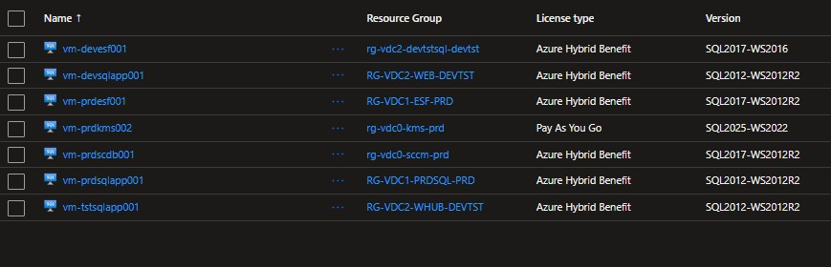

- Public network access on managed data services: 32 data services have public network access enabled. The Resource Graph export does not consistently populate this field for every record - the true number is likely higher. Combined with the fact that only 3 have "Azure AD authentication only" enforced, this represents a material identity-and-network exposure gap on data resources.
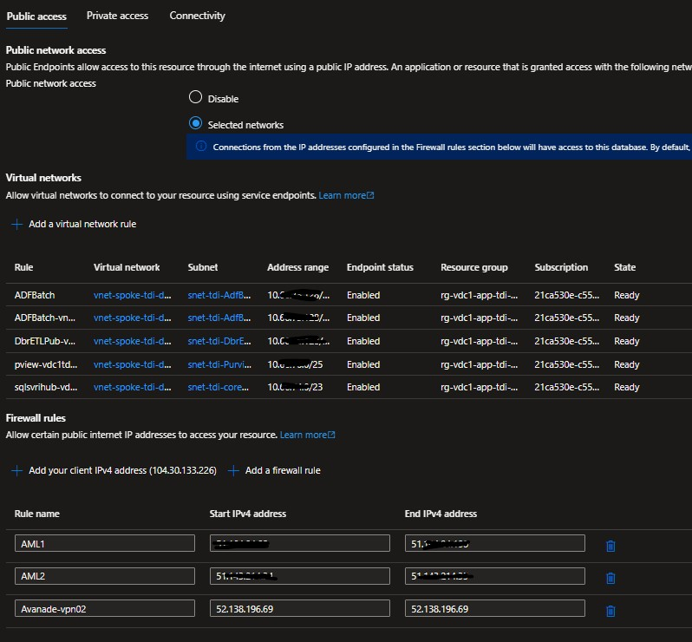

- Private Endpoint adoption on data tier: Of the 21 Private Endpoints terminating on SQL Servers, the connection success rate is high. Where SQL Servers have a Private Endpoint, network-level access is correctly mediated. However, the gap between PE-protected SQL
Servers and total SQL Servers is significant - not every server is private-endpoint addressable.
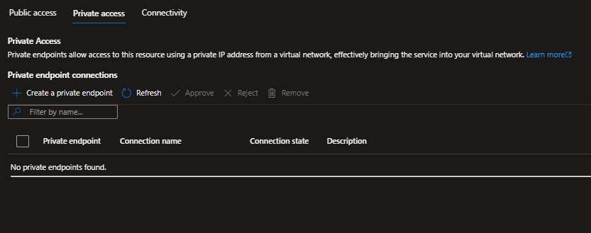

- PaaS adoption is strong: 40 SQL Databases and 1 SQL Managed Instance represent a healthy PaaS footprint.
- System Managed Keys:
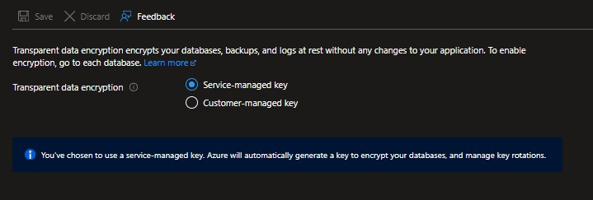

Key Metrics: Data Services – Databases
Metric | Value | Risk | Comment
Total data resources | 80 | - | -
SQL PaaS | 70 |  | SQL Database, Managed Instance or SQL Server
SQL IaaS | 7 | ● Medium | SQL Virtual Machine
Public Network Access - Enabled | 29 | ● High | Mixed implementation with  Vnet and Public Whitelisting
Azure AD Only Authentication | 3 / 80 | ● High
Minimum TLS 1.2 not enforced | 0 | - | All compliant where configurable
Risk Level - Medium | 29 / 80 | ● Medium
Risk Level - Low | 48 / 80 | ● Low
Private Endpoints Enabled | 0 / 80 | ● High | No Private endpoints for internal connectivity

Workload: Data Services, Data and AI Platform

Objective
Safeguard data tier with comprehensive protection and access controls.
- Enforce secure network access with private endpoints and firewall rules.
- Implement strong authentication using Azure AD integration.
- Ensure data protection with encryption at rest and in transit (TLS 1.2+).
- Enable threat detection and auditing for compliance and security monitoring.

Workloads in Scope
- Databricks
- Fabric
- Synapse Analytics
- Azure Data Factory
- Purview
- Machine Learning Studio
- Microsoft Foundry

Deployment Summary
Resource Type |  | Count | Flagged | Notes
Databricks | 24 |  | 23 | Consolidate workloads where appropriate
Fabric | 4 |  | - | Critical/Non-Critical larger workloads, Compute could be split, Prod and Non-Prod consideration
Synapse Analytics | 3 |  | - | Review Managed VNet configuration
Azure Data Factory | 21 |  | - | Consolidate workloads where appropriate
Purview | 2 |  | - | One per tenant, need to reconcile  to one
Machine Learning Studio | 13 |  | 13 | Historic AI/Data Science journey, many varied settings and nothing decommissioned
Microsoft Foundry | 5 |  | 4 | Historic AI/Data Science journey, many varied settings and nothing decommissioned
Total | 72 |  | - | -

Observations
- Databricks: Enabled public network access, enhanced security and compliance not enabled, no customer keys, diagnostic settings missing, no private endpoints, multiple failing Secure Score contributing factors. 24 Databricks instances in the tenant under multiple management group hierarchies.
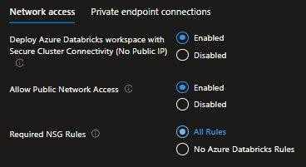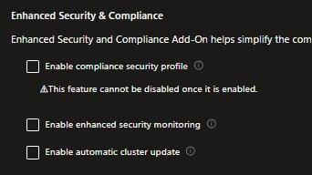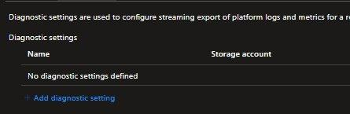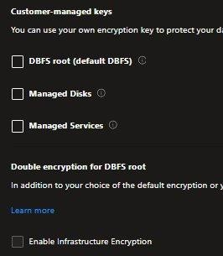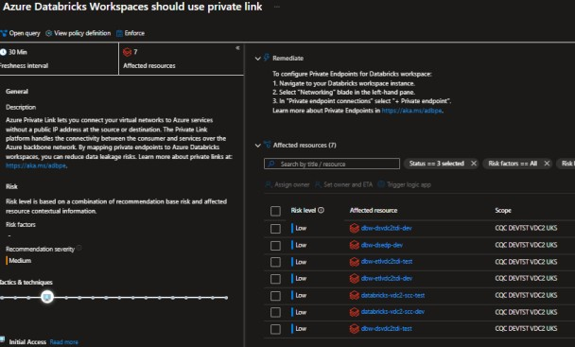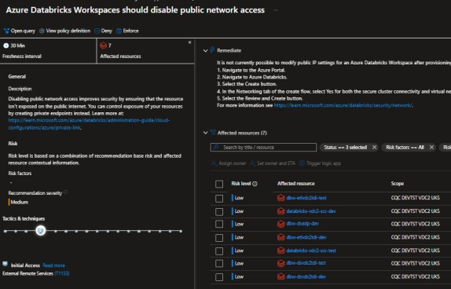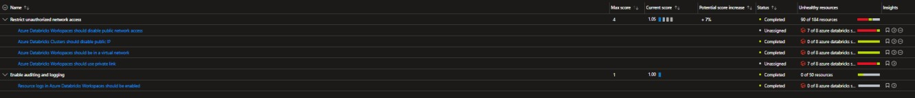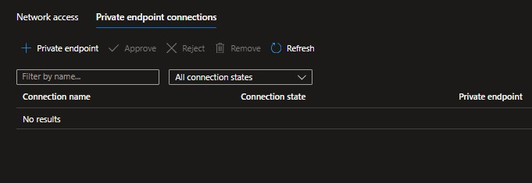

- Fabric: Multiple Prod capacities but no non prod capacities, large SKUs and lower numbers lean to the potential for workload collisions and performance problems. No evidence of scaling or pausing and resuming capacities leading to higher costing resources.
- Synapse Analytics: Managed VNet but has Public network access to workspace endpoints, Allow Azure Services and resources to access workspace, whitelisting IP addresses, No Data Exfiltration, No Azure SQL Auditing.
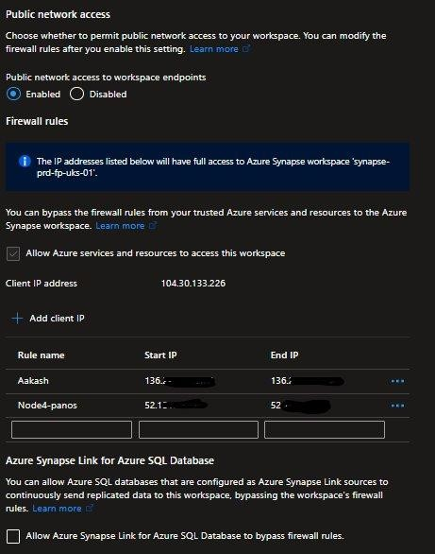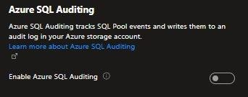

- Data Factory: Data Factory v2 spending of ~£80K/month is a substantial line item. SSIS Integration Runtime instances within Data Factory are particularly cost-sensitive and should be reviewed for utilisation - non-trivial savings are typically available by switching to auto-pause or reducing instance counts.
- Data Factory: Public Network Access, missing diagnostics.
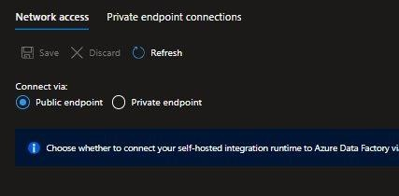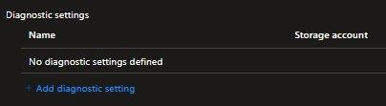
- Purview: 2 Instances in the tenant, one per tenant resource, both Legacy and Modern configuration, need to consolidate.
- Machine Learning Studio: Several instances have Public Network enabled from All Networks, others use a mix of public IP whitelisting, and only 1 has public network access disabled. Outbound access is allowed but restricted to approved locations only, and Diagnostic Settings are partially configured. Across the instances there are clear differences in implementation and configuration, with multiple training workspaces and legacy configurations.

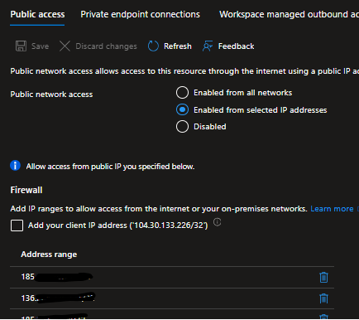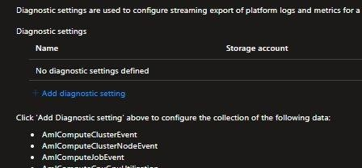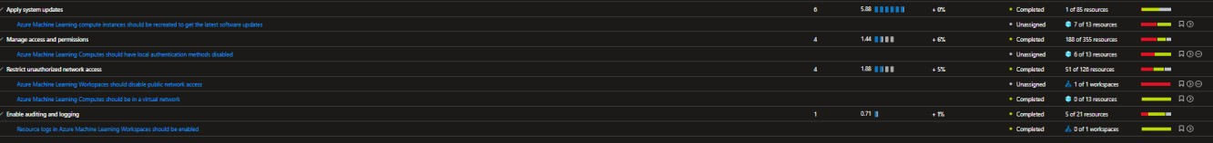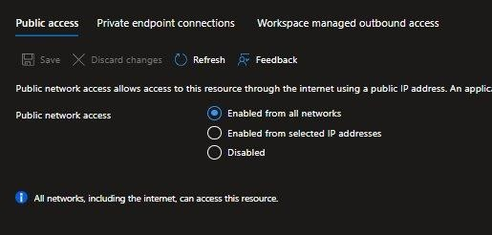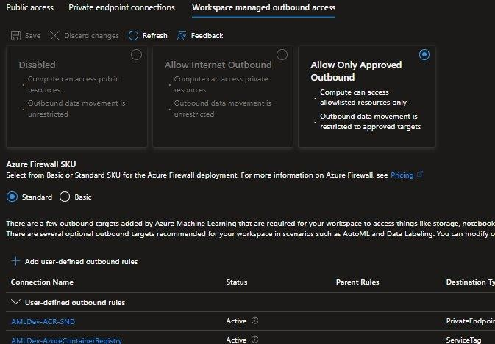

- Microsoft Foundry: Several instances with different configurations, hub, project and supporting resources in legacy and modern configurations. Public Networking on resources and no private endpoints at all on some instances. Managed VNet not enabled, allow azure resources to connect and network ingestion not enabled. Open AI resource deployment in particular in a legacy context without any Foundry surrounding it with Threat protection disabled and no diagnostic setting enabled.
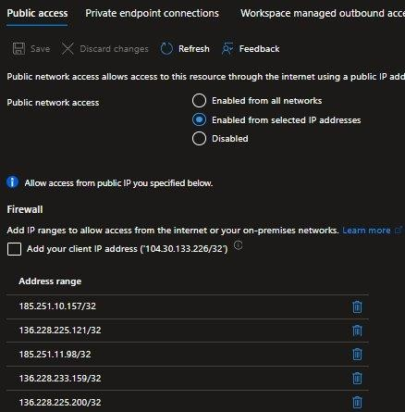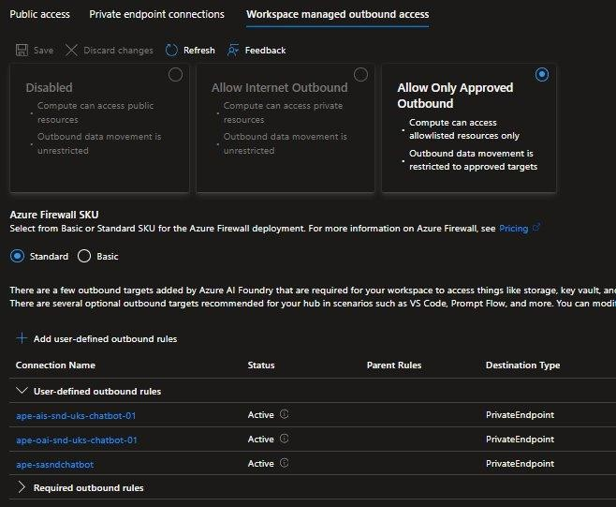
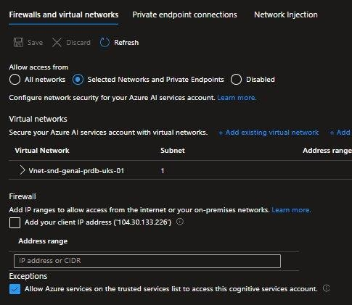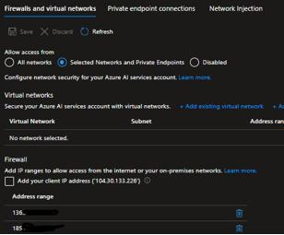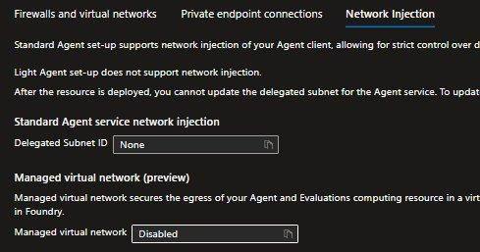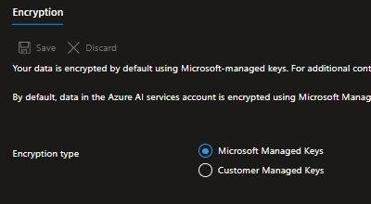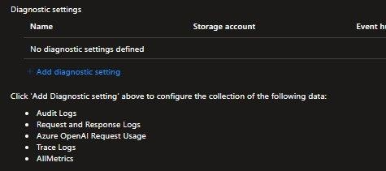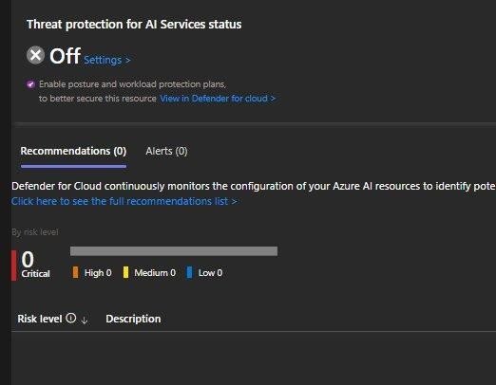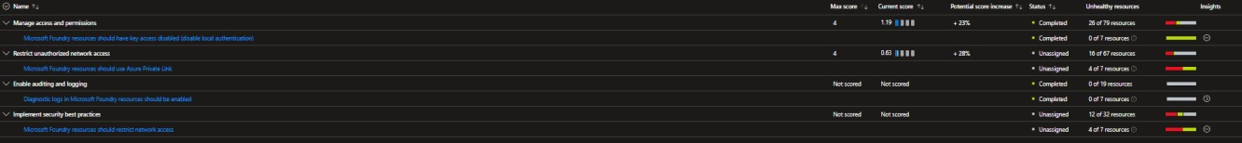

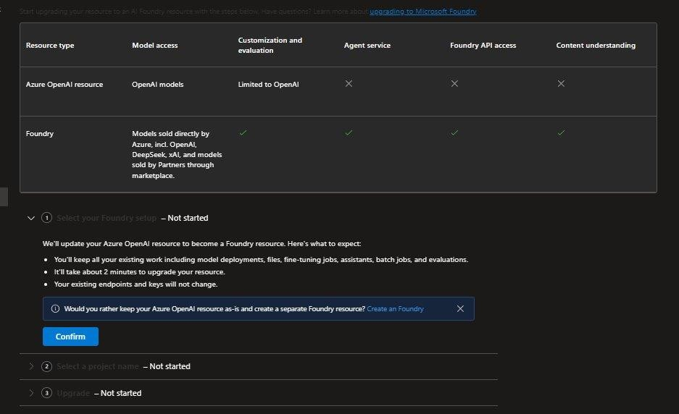
- PaaS adoption is strong: 3 Synapse Workspaces represent a healthy PaaS footprint. The Databricks footprint (visible in the cost data at ~£101K/month) is the modern analytics tier. The combination of Synapse + Databricks + Data Factory across the estate for analytics workload could be appropriate but could also be consolidated based on requirements and specific workloads.

Key Metrics: Data Services – Data and AI Platform Summary
Metric | Value | Risk | Comment
Total data resources | 72 | - | -
Databricks | 24 / 72 | - | Large number of Databricks instances
Fabric | 4 / 72 | - | -
Synapse Analytics | 3 / 72 | - | -
Azure Data Factory | 21 / 72 | - | Large number of Data Factory instances
Purview | 2 / 72 | - | -
Machine Learning Studio | 13 / 72 | - | -
Microsoft Foundry | 5 / 72 | - | -
Public Network Access - Enabled |  | ● High | Mixed implementation from  Public, Private Vnet with Allow Public, Private Vnet with Whitelisted rules,  Private with Managed Vnet
Private Endpoints Not Enabled | 47 / 66 | ● High | Low utilisation of Private endpoints for secure internal connectivity
Synapse Analytics DEP Not Enabled | 3/3 | ● Medium
Authentication Not Azure AD Only |  |  | Azure AD Only enabled for all relate data platform  services
SQL Auditing Not setup | 3/3 | ● Medium | Synapse Analytics not enabled
Enhanced Security and Compliance  Enabled | 0 / 24 | ● Medium | Databricks
Threat protection for AI Services status  Not Enabled | 4 / 4 | ● Medium
Risk Level - Medium | 40 / 72 | ● Medium | Databricks, Machine  Learning Studio, Microsoft  Foundry

Workload: Compute

Objective
To assess the efficiency, security, and operational maturity of the compute estate.
- Optimise Cost: Identify oversized resources and opportunities for modernisation (moving from legacy v3/v4 to v5 families).
- Secure the Workload: Validate network exposure, disk encryption, and OS compliance.
- Operational Excellence: Ensure consistent tagging for chargeback and validate backup/DR readiness.

Workloads in Scope
- Virtual Machines (Windows and Linux compute instances)
- VM Security (OS versions, encryption, network access)
- Network Security (NSGs, public IP exposure, private connectivity)

Observations

Security Posture
- Disk encryption is universal: 194 of 194 VMs have OS disk encryption enabled. This is the strongest single signal in the compute estate.
- Public exposure is contained: Only 5 VMs are publicly accessible. Where this occurs, it should be verified that the exposure is intentional (jump-box, public-facing web tier with WAF in front) rather than accidental.
- NSG coverage gap: 162 VMs have no NSG attached to their NIC. While the parent subnet may carry an NSG, NIC-level NSG provides defence in depth - particularly for VMs that live on shared subnets.
- Boot Diagnostics gap: 46 of 194 VMs do not have Boot Diagnostics enabled. Boot Diagnostics is essential for troubleshooting any VM that fails to boot - this should be enabled as a default policy.

Cost & Efficiency
- Burstable family is dominant: 104 of 194 VMs are Burstable (B-series) - appropriate for lowutilisation, latency-tolerant workloads. Burstable VMs cost less than equivalent General Purpose SKUs but accumulate "banking" credits - the credit balance and CPU steal should be monitored.
- Legacy SKU tail: Of 194 VMs, 24 are v2-family, 30 are v3, and 1 is v4, for a combined 55 VMs ripe for modernisation to v5. v5 typically offers 15-30% better price-performance over v3 on equivalent workloads, with no application changes required for most cases.
- Oversizing footprint: 3 VMs are flagged as oversized. While not large in absolute count, these typically represent the highest unit cost per VM - right-sizing them is the highest-ROI cost intervention available in the compute estate.
- Concentration in VDC subscriptions: 184 of 194 VMs live in the four VDC subscriptions. The compute footprint is highly concentrated - modernisation and right-sizing efforts will achieve maximum benefit if focused there first.

Operational Governance
- VMTier tagging is broken: 154 of 194 VMs have VMTier = "Unknown". Only 2 are explicitly tagged as Production. Tier classification is essential for differential patching policies, backup retention, and incident escalation - operating 154 VMs without a tier is an operational risk, not just a metadata gap.
- Backup coverage is incomplete: 158 backups are in the Suspended state and 32 have Protection Stopped. Of items in active protection, 45 report an Unhealthy last-backup status and 4 have a Failed last-backup. Production VMs without successful recent backup are a compliance risk for any regulator-supervised workload.
- No Cross-Region Restore: All 20 Recovery Services Vaults have Cross-Region Restore = Disabled. For a UK-South-only data residency posture, this is operationally consistent, but it means DR options are limited to in-region restore. A documented exception or a planned UKWest DR posture is needed.
- OS support: 124 of 194 VMs are reported as running supported operating systems. The remaining VMs should be inventoried by OS / version - particularly any Windows Server 2012 / 2012 R2 instances that have reached extended support end-of-life.

Key Metrics – VM’s

Key Metrics - Compute Estate Overview
Metric | Value | Risk | Comment
Total virtual machines | 194 | - | Estate size.
OS disk encryption enabled | 194 of 194 (100%) | ● Good | Data at rest fully protected.
Publicly accessible | 5 of 194 (2.6%) | ● Medium | Direct internet exposure.

Key Metrics - VMs per Size Category
Size Category | Count of VMs
Burstable | 104
General Purpose | 46
Memory Optimized | 35
Other | 6
Compute Optimized | 3
Grand Total | 194

Family Modernisation Status
VM Family | Count | Modernisation Status
No version | 94 | No version detected - review
v5 | 45 | Modern - preserve
v3 | 30 | Legacy - modernise to v5
v2 | 24 | Legacy - modernise to v5
v4 | 1 | Consider modernisation to v5

Key Metrics - VM SKU Breakdown
Subscription | Branch | Stan dar d_B 1ms | Stan dar d_B 2ms | Stan dar d_E 8ds_ v5 | Stan dar d_D 2s_v  3 | Stan dar d_D 8s_v  3 | Stan dar d_B  2ls_ v2 | Stan dar d_E 42ds_ v5 | Stan dar d_B 4ms | Stan dar d_D 8ds_ v5 | Stan dar d_B  2s | Oth  er | Tota  l
CQC PRD VDC0  UKS | mg-cqc-legacy | 28 | 10 | 0 | 4 | 3 | 2 | 0 | 0 | 0 | 0 | 24 | 71
CQC PRD VDC1  UKS | mg-cqc-legacy | 20 | 2 | 10 | 2 | 1 | 2 | 2 | 2 | 2 | 1 | 11 | 55
CQC DEVTST  VDC2 UKS | mg-cqc-legacy | 10 | 0 | 1 | 4 | 3 | 1 | 1 | 2 | 1 | 2 | 12 | 37
CQC UAT VDC3  UKS | mg-cqc-legacy | 6 | 2 | 3 | 2 | 0 | 1 | 2 | 0 | 2 | 1 | 2 | 21
MHA SOAD  Portal(Conver | mg-cqc-legacy | 4 | 0 | 0 | 0 | 0 | 0 | 0 | 0 | 0 | 0 | 3 | 7
CQC-Prod-MNSI | mg-cqc-legacy | 0 | 0 | 0 | 0 | 0 | 0 | 0 | 1 | 0 | 0 | 0 | 1
cqc-snddatasciencetra | mg-cqc-root | 0 | 0 | 0 | 0 | 0 | 0 | 0 | 0 | 0 | 1 | 0 | 1
sub-siebel-prd-  001 | mg-cqc-root | 0 | 1 | 0 | 0 | 0 | 0 | 0 | 0 | 0 | 0 | 0 | 1
Grand Total | - | 68 | 15 | 14 | 12 | 7 | 6 | 5 | 5 | 5 | 5 | 52 | 194

FinOps and Cost Management

Objective
Establish financial transparency and cost control across the Azure estate by assessing cost allocation, spend efficiency, and optimisation practices.
- Provide visibility into cloud spend across subscriptions, environments, and services.
- Evaluate cost allocation effectiveness through tagging, chargeback / showback readiness, and management group alignment.
- Identify high-cost services, usage anomalies, and spend trends.
- Assess adoption of cost optimisation mechanisms such as reservations, savings plans, and autoscaling.
- Identify underutilised, idle, or orphaned resources contributing to unnecessary cost.
- Establish a baseline for FinOps maturity and identify opportunities to improve ongoing financial governance.

Workloads in Scope
• All azure resources

Observations
Total Azure spend across the eleven complete months (April 2025 to February 2026) was £2.00M, an average run rate of £182K per month and an annualised position of approximately £2.19M. Spend is stable month on month (range £171K to £195K).

- Data and Analytics is the largest spend, £534K (26.6%, £48.5K per month). Four services account for most of it: SQL Database (£171K), Microsoft Fabric (£121K), Azure Databricks (£101K) and Azure Data Factory v2 (£80K). The leverage sits in two places, Fabric capacity SKU sizing and SQL service tier sizing.
- Compute is second, £435K (21.7%, £39.5K per month). The spend splits across Virtual
Machines (£189K), App Service (£110K) and Logic Apps (£106K). The virtual machine line is the VDC0 and VDC1 production estate, where v5 family right sizing and Azure Hybrid Benefit are the obvious paths. Logic Apps spend is high for a platform with no API authentication discipline (Defender chapter, §6.3), so usage and authentication are best looked at together.
- Networking is expensive, £361K (18.0%, £32.8K per month). VPN Gateway alone accounts for £123K, 6.1% of total Azure spend, with API Management (£112K) and Application Gateway (£42K) behind it.
- Storage and Backup, £329K (16.5%, £30.0K per month). The spend splits between storage (£240K) and backup (£89K). The levers are lifecycle policies, cool and archive tiering on append only data, and decommissioning the backups still held against the 190 suspended or stopped protected items.
- Defender for Cloud is the entire security spend, £133K (8.0% of total). Because none of the inspected resources have diagnostic settings configured (Defender chapter), most of this spend produces signal the SOC cannot act on. The plans are worth rationalising one by one, starting where adoption is thin such as Containers, before the diagnostics rollout grows the bill further.
- Spend is concentrated in the legacy VDC subscriptions. PRD VDC0 (£38K), PRD VDC1 (£30K),
DEVTST VDC2 (£23K) and UAT VDC3 (£13K) lead the list. Together the top four account for £104K of the £152K current period snapshot (68%). The VDC to CAF migration is the single largest cost optimisation lever the platform has.
- Workload level cost transparency is missing. With no CostCenter or BusinessOwner tag (Cloud Governance chapter), spend cannot be charged or shown back to a workload owner, and every cost review depends on manual subscription reconciliation. This is the highest leverage FinOps governance change.

Key Metrics: Total Spend & Run Rate
Metric | Value
April 2025 spend (baseline month) | £179,553
Mean monthly spend (Apr 2025, Feb 2026) | £182,071
Lowest month (Feb 2026) | £170,847
Highest month (Jul 2025) | £194,969
Total 11-month spend (Apr 2025, Feb 2026) | £2,002,781
Annualised run rate (12-month projection) | £2.185M

Key Metrics: Top Cost Drivers by Service
# | Service | 11-mo Total | Monthly Avg | % of Total
1 | Storage | £240,254 | £21,841 | 12.0%
2 | Virtual Machines | £189,379 | £17,216 | 9.5%
3 | SQL Database | £170,828 | £15,530 | 8.5%
4 | Microsoft Defender for Cloud | £133,407 | £12,128 | 6.7%
5 | VPN Gateway | £122,713 | £11,156 | 6.1%
6 | Microsoft Fabric | £121,492 | £11,045 | 6.1%
7 | API Management | £111,701 | £10,155 | 5.6%
8 | Azure App Service | £109,974 | £9,998 | 5.5%
9 | Logic Apps | £105,695 | £9,608 | 5.3%
10 | Azure Databricks | £101,091 | £9,190 | 5.0%
11 | Backup | £89,229 | £8,112 | 4.5%
12 | Azure Data Factory v2 | £79,876 | £7,261 | 4.0%
13 | Azure DevOps | £65,539 | £5,958 | 3.3%
14 | Log Analytics | £57,067 | £5,188 | 2.8%
15 | Service Bus | £52,163 | £4,742 | 2.6%

Key Metrics: Top Cost Drivers by Subscription
# | Subscription | Branch (Mgmt Group) | Current Cost
1 | CQC PRD VDC0 UKS | CoreInfrastructure | £38,239
2 | CQC PRD VDC1 UKS | ProdApps | £29,519
3 | CQC DEVTST VDC2 UKS | DevTest | £23,211
4 | cqc-prd-ais | ProdApps | £12,876
5 | CQC UAT VDC3 UKS | UATApps | £12,584
6 | cqc-preprod-ais | ProdApps | £6,134
7 | cqc-tst-ais | DevTest | £5,658
8 | cqc-dev-ais | DevTest | £5,438
9 | cqc-snd-datasciencetraining | mg-sandbox | £2,225
10 | cqc-plat-connectivity | mg-connectivity | £1,550
11 | CQC-QA-RP-UKS | mg-cqc-legacy | £1,385
12 | CQC-Prod-FinanceProgramme | ProdApps | £1,289
13 | CQC-PREPROD-RP-UKS | mg-cqc-legacy | £888
14 | CQC-DEV-RP-UKS | DevRP | £878
15 | CQC-INTEGRATIONSERVICES-DEV-UKS | mg-cqc-legacy | £775
- | Top 5 subscriptions combined | - | £116,430  (76.7%)
- | All 65 subscriptions | - | £151,832

Key metric, Resource & Cost Distribution by environment
Environment | Subs | Resources | Monthly Cost
Legacy (Unclassified) | 19 | 1,865 | £7,405
Dev/Test (Legacy) | 6 | 1,664 | £36,292
Production (Legacy) | 5 | 1,486 | £49,886
Core Infra (Legacy) | 1 | 1,099 | £38,239
UAT (Legacy) | 1 | 378 | £12,584
Development RP (Legacy) | 1 | 320 | £878
GFC (Legacy) | 3 | 233 | £1,280
Sandbox | 2 | 225 | £2,397
Identity (Platform) | 2 | 182 | £3
Production (mg-cqc-root) | 10 | 150 | £277
Management (Platform) | 2 | 121 | £78
Connectivity (Platform) | 2 | 56 | £2,171
Test (mg-cqc-root) | 2 | 21 | £0
Security (Platform) | 1 | 17 | £0
Root (Bootstrap) | 2 | 14 | £109
Development (mg-cqc-root) | 2 | 8 | £70
Pre-Production (mg-cqc-root) | 1 | 0 | £0
Decommissioned | 3 | 0 | £0

Health Check Conclusions / Final observations

Maturity Scorecard
The scorecard below summarises the current and target maturity state for each HCAF pillar.
The maturity model is a 5-level scale:
Level | Name
1 | Initial
2 | Developing
3 | Defined
4 | Managed
5 | Optimised

Maturity Scorecard - Results
Pillar | Current Level | Target Level | Evidence
Cloud Governance | (2) Developing | Managed | Three parallel Management Group hierarchies in flight; 19 subscriptions sitting directly under mgcqc-legacy; two subscriptions bypassing all  Management Group policy
FinOps and Cost  Management | (2) Developing | Defined | £2.185M annualised spend with zero CostCenter or BusinessOwner tag coverage; no budgets configured at Management Group level
Management and  Monitoring | (1) Initial | Defined | Defender enabled on 61 of 65 subscriptions, mean Secure Score 59.8% against 75% target, 100% of 1,461 inspected resources have no diagnostic settings.
Identity and Access  Management | (1) Initial | Defined | Service principals outnumber humans 7 to 1, 813 of 1,219 broad-scope grants flagged (66.7%), 163 Classic Administrator grants, no PIM coverage.
Network Security | (2) Developing | Managed | Six hubs, hub VNet 35% subnet NSG coverage, 34 isolated VNets (47%), NSG 21% full and 32% average, all four firewalls Standard tier with no IDPS or TLS inspection.
External Exposure | (2) Developing | Managed | 0 of 40 Public IPs on DDoS Standard, all firewalls at 50% config score (Fair), 7 WAF policies in place but 1 production policy in detection mode and 0 custom rules.
Secret and Key  Management | (1) Initial | Managed | 107 of 118 Key Vaults allow public network access, 66 without Purge Protection, 86 on legacy Access Policy model. Soft Delete universal and new platform vaults correct.
Data Services | (2) Developing | Defined | 32+ data services with public network access, only 3 enforcing AAD-only auth, 7 SQL VMs pending modernisation, Databricks, Synapse, and
 |  |  | Foundry publicly exposed with missing diagnostics.
Compute | (3) Defined | Managed | Disk encryption 194 of 194 (strong), but 162 VMs without NIC NSG, 154 VMTier "Unknown", 190 backups suspended or stopped, 55 legacy-family VMs pending v5 modernisation.
Application Services | (1) Initial | Defined | Platform authentication disabled on 161 of 161  Function Apps, public access on 98.1%, all 12 APIM instances public with no auth, 206 unstandardised App Service Plans, entire estate on retiring hierarchies.
Storage | (2) Developing | Managed | 609 of 665 accounts (91.6%) fail at least one control, shared-key auth 70.4%, public network 58%, anonymous blob 17.1%, 54 critical exposures. HTTPS and TLS 1.2 floor consistent.
Operations and Backup | (2) Developing | Managed | 547 alert rules and 110 action groups deployed but zero ITSM integration; Cross-Region Restore disabled on all 20 RSVs; 41% of backup items not actively protected
Overall Estate | (2) Developing | Managed | Strong target architecture undermined by a legacy estate carrying the bulk of resources, cost, and risk. Maturity gated on completing the CAF migration and enforcing target-state controls through policy.

Contacts
For further information, please contact:

Jesmond Giordmaina
Technical Director

Hitachi Solutions
London office
110 Bishopsgate
23rd floor
London UK
EC2N 4AY

Email: jgiordmaina@hitachisolutions.com
Mobile: +7825 996 838
Office: +44 (0)204 526 8510

Change History

Date | Name | Version | Change Reference
9th June 2026 | Jesmond Giordmaina | 0.1 | Initial Release for feedback.

